SYDNEY NORTH REGIONAL PLANNING PANEL - ASSESSMENT REPORT
Panel Reference | PPSSNH-426
DA Number | 20230094
LGA | Hunters Hill
Proposed Development | Alterations and additions to the existing Woolwich Marina to expand the berthing facilities from 45 to 79 berths to enable a range of different vessel typologies (ranging in size from 10m to 35m in length).
Street Address | 2 C Margaret Street, Woolwich, legally described as Lots 2, 3 and 4 in DP880264 with an offshore component described as Lot 1 in DP1203041.  Lot 1 in DP1203041 is subject to the following NSW Maritime Leases:  - Lease No. RP5298 (marina component)  - Lease No. CL6104 (swing mooring field)
Applicant | Rhonda Carr (of Michael Fountain Architects Pty Ltd)
Owner | Chan No. 1 Investments Pty Ltd  The State of NSW
Date of DA lodgement | 12 July 2023
Capital Investment Value | $8,508,246.51 (excl. GST but incl. professional fees)
Number of Submissions | In total, Council received the following submissions:  - 121 in objection  - 311 in support (comprised of only 3 unique submissions and 308 form letters, counted as a single unique submission).
Recommendation | Refusal
Regional Development Criteria (Schedule 7 of the SEPP (State and Regional Development) 2011 | Schedule 7, Cl. (1)(b) – Marinas triggering Designated Development – under Schedule 3, Section 32(2)(b)(ii) of the Environmental Planning and Assessment Regulation 2021 – carparking to vessels ratio less than 0.5:1
List of all relevant s4.15(1)(a) matters | - SEPP (Biodiversity and Conservation) 2021  - SEPP (Resilience and Hazards) 2021  - SEPP (Transport and Infrastructure) 2021  - Hunters Hill Local Environmental Plan 2012 (HHLEP 2012)  - Hunters Hill Development Control Plan 2013 (HHDCP 2013)  - Sydney Harbour Foreshores and Waterways Area Development Control Plan 2005  - Hunters Hill Section 7.12 Local Infrastructure Contribution Plan 2020
List all documents submitted with this report for the Panel’s consideration | - Environmental Impact Statement and Appendices  - Applicant’s submission to DCCECW  - Applicant’s Submission to Heritage NSW  - Copy of all submissions
Clause 4.6 requests | - N/A
Summary of key issues | - Adequacy of the submitted documentation.  - Permissibility  - Environment Protection and Biodiversity Conservation Act 1999 (Cwth) and potential Matters of National Environmental Significance  - Waterway safety and navigational issues  - Impacts on Heritage Items and Conservation Area  - Adverse visual impacts  - Traffic and parking impacts  - Private Vs public use of a public asset/ public interest  - Impact of patrons from charter/ party boat use on surrounding neighbourhood amenity  - Precedence from similar NSW Land and Environment Court Decisions  - Resident Objections – 117 in objection with 3 unique submissions in support plus form letters signed by 285 individuals. The identity, status as residents of NSW and physical location of those submitters supporting the proposal could not be verified.
Report prepared by | Michael Brewer, Consultant Planner for Hunters Hill Council
Report date | 14 February 2024

SUMMARY OF S4.15 MATTERS:
Have all recommendations in relation to relevant s4.15 matters been summarised in the Executive Summary of the assessment report? | YES
Legislative clauses requiring consent authority satisfaction  Have relevant clauses in all applicable environmental planning instruments where the consent authority must be satisfied about a particular matter been listed, and relevant recommendations summarized, in the Executive Summary of the assessment report? | YES  However, the proposal fails to satisfy multiple provisions of the applicable EPIs and policy documents or provide necessary information. Accordingly, the Panel cannot be satisfied the proposal has met the appropriate standards or will be capable of achieving the required outcomes.
Clause 4.6 Exceptions to development standards  If a written request for a contravention to a development standard (clause 4.6 of the LEP) has been received, has it been attached to the assessment report? | N/A
Special Infrastructure Contributions  Does the DA require Special Infrastructure Contributions conditions (S7.24)?  Note: Certain DAs in the Western Sydney Growth Areas Special Contributions Area may require specific Special Infrastructure Contributions (SIC) conditions | No
Conditions  Have draft conditions been provided to the applicant for comment? | NO – recommendation for refusal

- EXECUTIVE SUMMARY:
Reasons for Report:
This report has been prepared as the Sydney North Regional Planning Panel, and not Council, is the Consent Authority in this instance. The proposal is classified as Regionally Significant Development and Designated Development as the ratio of onsite carparking to the number of vessels at the marina is less than 0.5:1.
Key Issues Summary:
The assessment of the proposal has identified the following key areas of concern that in Council’s view, warrant refusal of consent:
- Permissibility, fettering of adjoining areas and adequacy of the project’s justification.
- Failure to adequately address the Matters of National Environmental Significance.
- Adverse waterway safety and navigational issues.
- Adverse heritage impacts on Items of local, State, National and International significance.
- Adverse visual impacts.
- Traffic and parking impacts.
- Alienation of a public waterway for private gain and the public interest.
- Amenity impacts from patrons from charter/ party boat use on surrounding neighbourhood and aquatic environment.
- The learnings/ implications from relevant NSW Land and Environment Court Decisions regarding the above matters.
- Public submissions. Council Received 121 unique submissions in objection in addition to 3 unique submissions and 308 form letters in support of the proposal.
Public Submissions Summary:
Unsurprisingly, the issues raised in the submissions can, in essence, be categorised under most of the key issues identified above, including:
- Failure to satisfy the applicable environmental planning controls.
- Adverse waterway congestion, safety and navigational issues and impacts on small watercraft and junior sailors.
- Adverse heritage impacts on Items of local, State, National and International significance.
- Adverse visual impacts from public spaces and private properties and the loss of the visual connection between Kellys Bush and the water.
- Traffic and parking impacts including failure to take into account the marina becoming a de facto passenger terminal for large numbers of guests joining the larger vessels.
- Alienation of a public waterway for private gain and the public interest.
- Amenity impacts from patrons from charter/ party boat use on surrounding neighbourhood and aquatic environment.
- The learnings/ implications from relevant NSW Land and Environment Court Decisions regarding the above matters.
- Intensification of patrons on weekends and special events such as New Year’s Eve etc or the increased demand for trade and service vehicles catering to additional boats.
- Lack of demonstrated actual demand for the proposal
- Increased environmental effects from more boats being cleaned, increased waste streams and the management of waste and risk of pollution events.
- The proposal will be significantly exposed to wash from passing ferries and seasonal wind and wave-generated impacts.
- Lack of consultation with the wider sailing community who race or train through the adjoining waters and failure to capture decades of sailing and boating experiences within the clubs provide input into the proposal.
- The large vessels will be of a size, bulk and scale that they will obscure views across the waterway when using the adjacent foreshore park and the increased density of the swing mooring field has not been taken into account.
- The operations at the existing Marina are non-compliant with their existing approvals.
Key elements of support for the proposal raised were notably vague and without qualification, claiming that the proposal will:
- Enhance the overall quality of life for everyone in the community through a positive impact on the local economy.
- Strengthen social fabric and foster a thriving environment for both residents and visitors, providing a vibrant social hub for the community.
- Enable more of the community to access the Harbour in a safe and managed way.
- Include technologies committed to environmental sustainability.
- Cause a surge in the activity at the marina as it will address existing current shortfall of boating infrastructure by future proofing the marina.
- Likely attract sailing clubs and boating associations, leading to more social events, regattas, and gatherings that will foster a lively and enriching community spirit.
Many of the matters identified in these submissions also infer the marina introducing activities or operating in a manner for which approval is not sought by this approval. Additionally, with respect to the form letters, the identity, status as residents of NSW and physical location of those submittors could not be verified and these submissions should be weighed accordingly.
Importantly, a review of the Consultation Outcomes Report (Appendix K) has identified various gaps or incomplete responses that the applicant has not addressed, including demonstrating planned consultations occurred and obtaining formal comments from a number of government agencies. This also infers that the proponent has not satisfies the SEARS, has not adequately demonstrated the proposal is suitable for the Site or will be without significant adverse effects. Accordingly, the proposal is not supported by sufficient documentation and that the Panel cannot be satisfied therefore that the relevant statutory tests have been met.
External Agency Engagement:
Council engaged with the following external agencies as part of its assessment of the application:
- Heritage NSW.
- Transport for NSW - Land and Maritime Planning – (as a land owner).
- Transport for NSW (Maritime) – Manager Waterways Operation – Sydney Harbour.
- Transport for NSW (Maritime Planning and Consent Authority – Infrastructure and Place).
- Department of Climate Change, Energy, the Environment and Water (DCCEEW).
Internal Department Referrals:
The application was referred to the following internal departments for comment:
- Development Engineer.
- Heritage Advisor.
- Conservation Advisory Panel.
- Environmental Health and Building
Recommendation – Refusal:
Having reviewed the application against the relevant and applicable statutory provisions and considered the information submitted (or lack thereof), as well as having given due regard to all of the submissions received, it is considered that in the particular circumstances of the case, the Panel cannot be satisfied that the proposal has either:
- Engaged with and obtained the requirements of or input from all identified agencies, stakeholders or the community.
- Provided adequate information to demonstrate that all relevant statutory provisions have been addressed.
- Demonstrated that it will not have a significant adverse impact on the biophysical environment.
- Demonstrated that the subject Site is appropriate or suitable.
- Has sufficient planning merit to warrant approval.
The proposal cannot be mitigated or modified to deliver acceptable or desirable environmental planning outcomes and accordingly, refusal is recommended.
FIGURE 1 – THE EXISTING MARINA
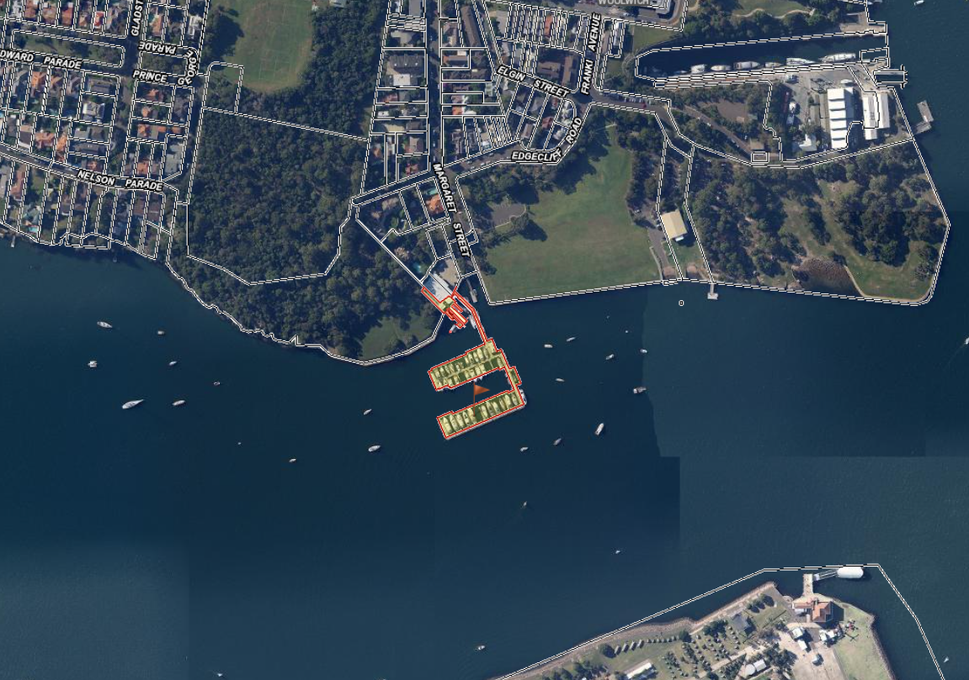
SOURCE: NSW SPATIALVIEWER 2023

- DESCRIPTION OF THE PROPOSAL:
The application proposes to undertake alterations and additions to the existing Woolwich Marina in order to expand the berthing facilities available for a range of different vessel typologies, ranging in size from 10m to 35m in length.
Specifically, the proposed development seeks consent for the following:
- Relinquishment of 2 existing swing moorings (resulting in a total of 8 swing moorings owned by Woolwich Marina).
- Relocation of 9 existing swing moorings, including:
- 8 moorings owned by Woolwich Marina.
- 1 emergency mooring.
- Addition of new marina arms to the west and south of the existing arms, with a total of 36 new floating berths (resulting in a total of 71 berths).
- Provision of 8 additional parking spaces on the existing hardstand to the northeast of the marina building (resulting in a total of 20 parking spaces).
Overall, the development will increase the storage capacity of the marina from a total of 45 to 79 vessels (including marina berths and swing moorings). The only works above the mean high water mark will be the line markings of the proposed car parking spaces.
FIGURE 2 - PROPOSED SWING MOORING CHANGES:

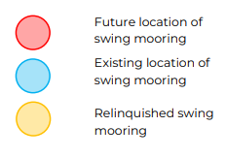
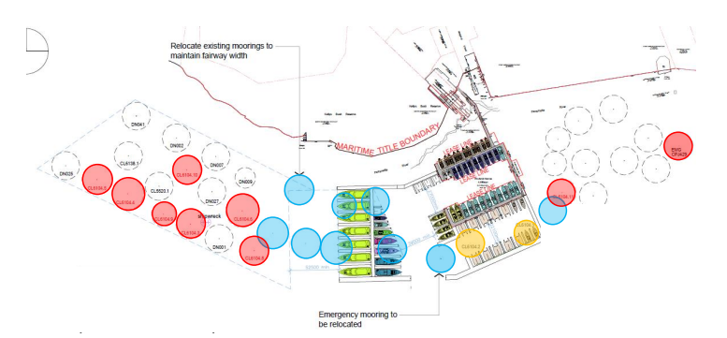
Retained Moorings not owned by Marina
FIGURE 2 - PROPOSED BERTHING LAYOUT:
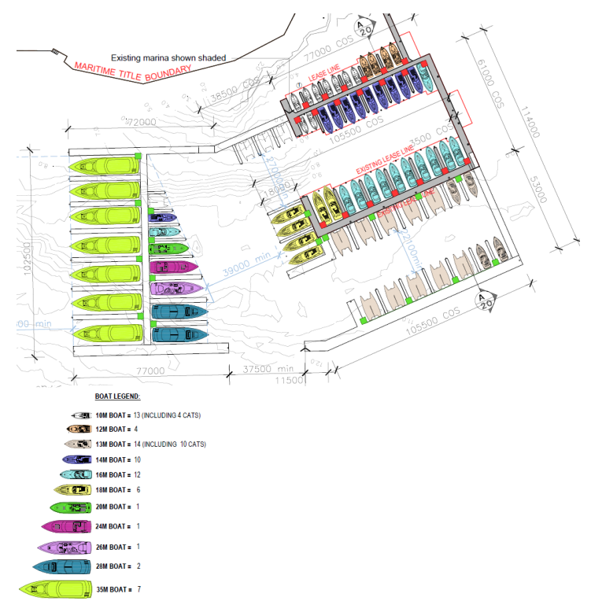
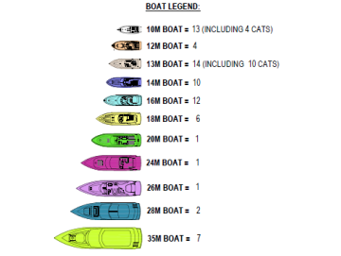

FIGURE 4 - PROPOSED CAR PARK CHANGES:
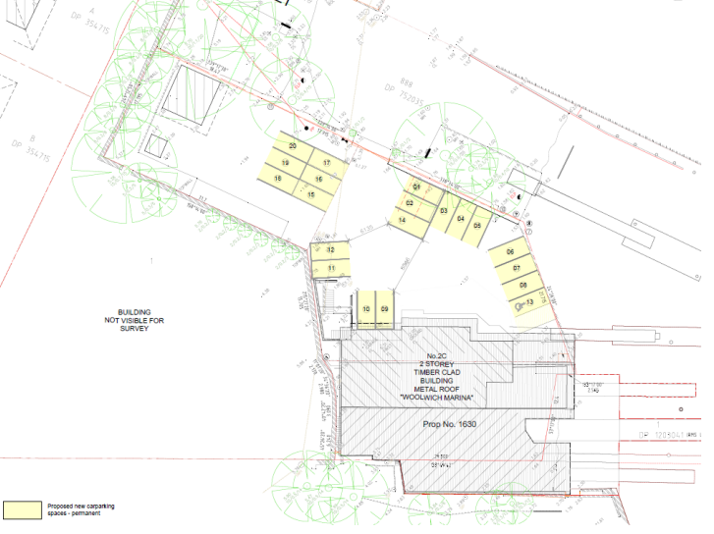
FIGURE 5 – TENURE PLAN – EXISTING AND PROPOSED
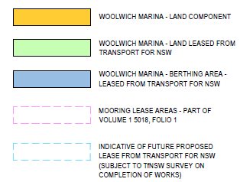
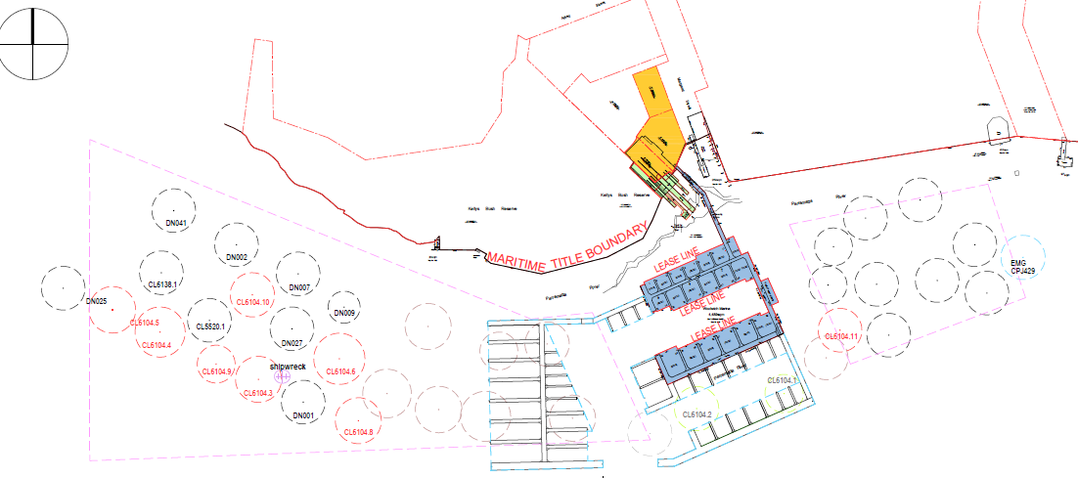
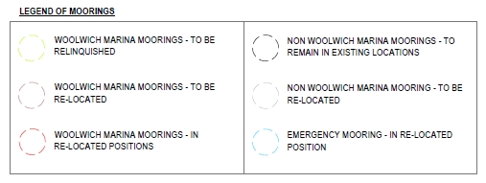
FIGURE 6 – ELEVATIONS
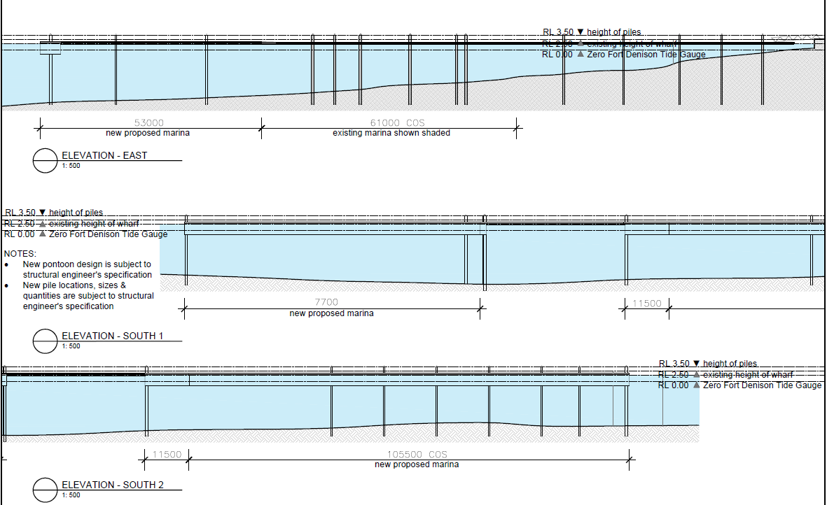
FIGURE 7 – ELEVATIONS
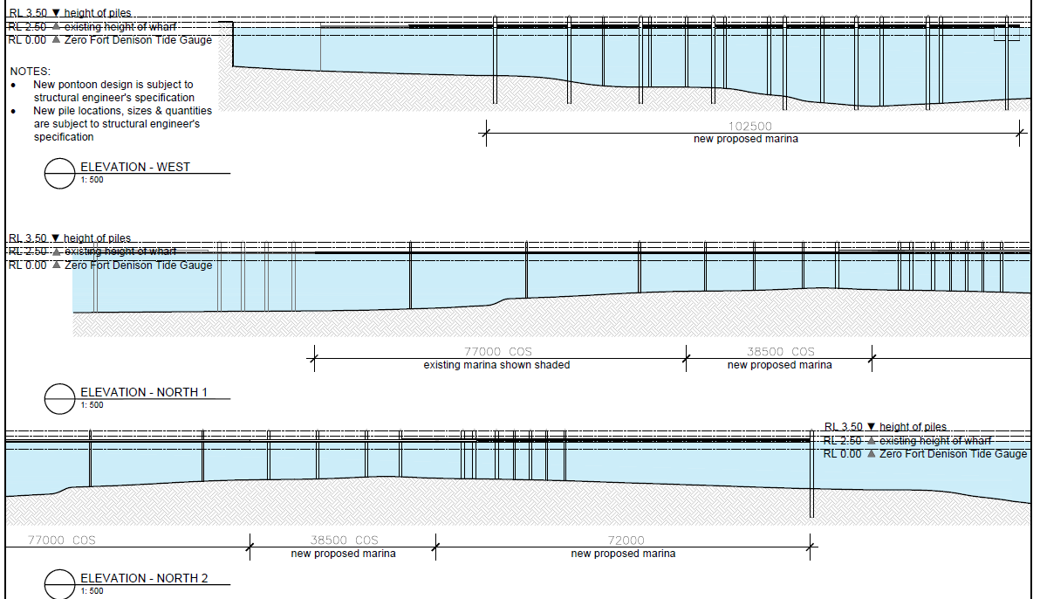

FIGURE 8 – SECTIONS
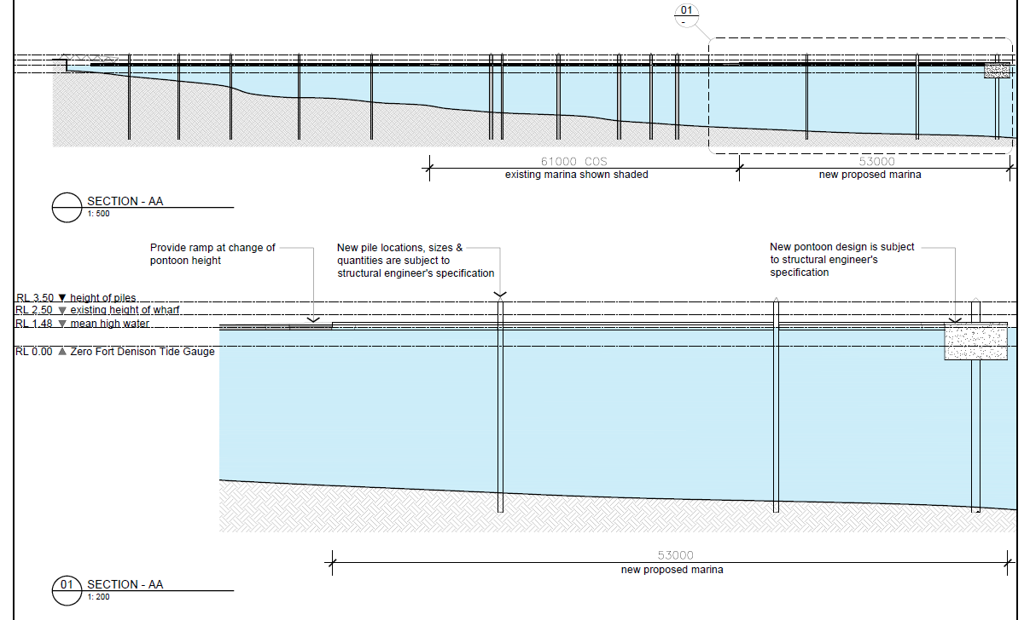

- DESCRIPTION OF THE SITE AND LOCALITY

The Site:
The Site, as shown in Figures 9, 10 and 11 below, is known as 2C Margaret Street, Woolwich, located within the Local Government Area of Hunters Hill. It is legally described as Lots 2, 3 and 4 in DP880264 with an offshore component described as Lot 1 in DP1203041.
Lot 1 in DP1203041 is subject to the following NSW Maritime Leases:
- Lease No. RP5298 (marina component).
- Lease No. CL6104 (swing mooring field).
FIGURE 9 – THE EXISTING MARINA
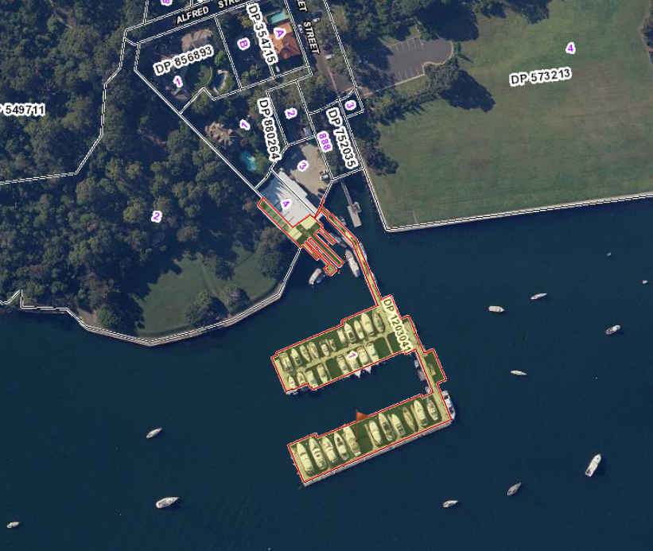
SOURCE: WWW.MAPS.SIX.NSW.GOV.AU 2023
Existing development includes a two (2) storey building on the land-based component, which operates as the marina manager’s residence and administration offices, work sheds, 12 carparking spaces and watercraft storage. Three (3) slipways are also provided within the main marina building to the west of the existing marina.
The water-based component of the site currently comprises two (2) marina arms accommodating 35 berthed vessels, with a maximum vessel size of 18m. These marina arms are located approximately 70m and 130m respectively from the marina building on the shore.
FIGURE 10 – THE DEVELOPMENT SITE
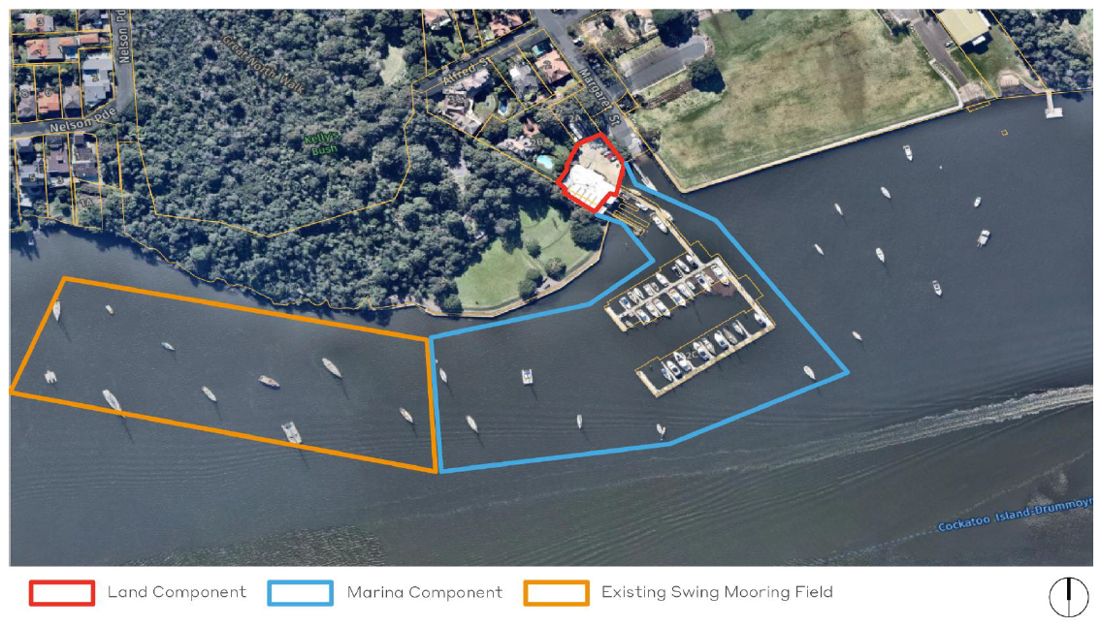
SOURCE: ENVIRONMENTAL IMPACT STATEMENT PREPARED BY ETHOS URBAN
The Site is set on the western end of Margaret Street, which lies on the southern side of the Woolwich Peninsula. It lies immediately to the east of the State Heritage-listed Kelly’s Bush Reserve and to the immediate west of the Woolwich Boat Ramp. Adjacent to the east lies the Woolwich Dock and Parklands which include an open tract of parkland known as the Horse Paddock, Clarke’s Point Reserve and the former docks themselves. The Dock and Parklands are listed as a Commonwealth Heritage Place. The southern portion of Woolwich residential area lies to the immediate north of the Site, as shown in Figure 11 below.

FIGURE 11 – THE IMMEDIATE LOCALITY
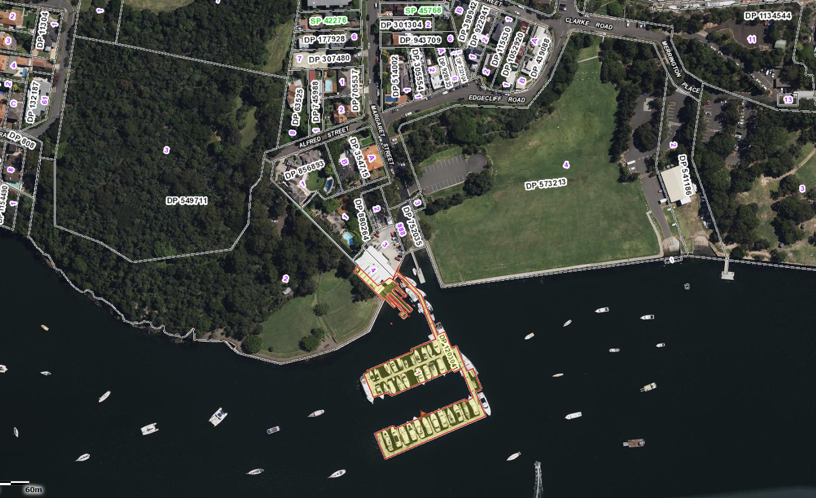
SOURCE: WWW.MAPS.SIX.NSW.GOV.AU 2024
FIGURE 11 – THE WIDER LOCALITY
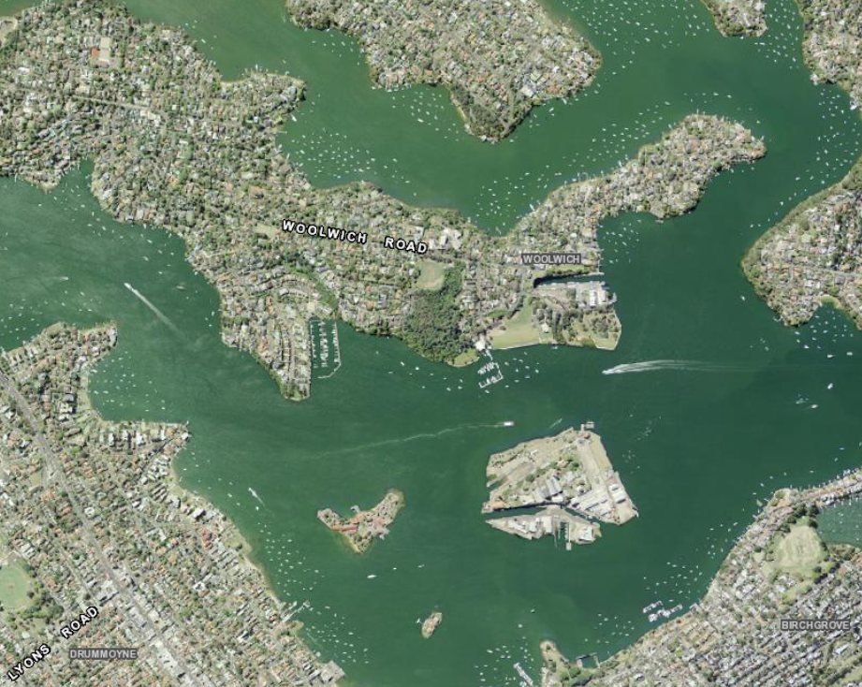
SOURCE: WWW.MAPS.SIX.NSW.GOV.AU 2024
- RELEVANT STATUTORY FRAMEWORK:
It is note that Section 4 of the EIS identifies a range of statutory measures to be addressed before delving into the assessment of the proposal in terms of the statutory planning matters or impacts likely to occur. With due regard to Section 4 of the EIS, the following is noted:
- The definition of the proposed development is agreed as a “Marina”.
- The Site is divided into two components- one water-based, the other land-based. The water-based component is zoned as Zone 1 – Maritime Waters, Zone 5 – Water Recreation and importantly, Zone 8 -Scenic Waters – Passive Use under SEPP (Biodiversity and Conservation) 2021, as per Figure 12 below, while the land-based component is zoned as Zone W4 – Working Waterfront (originally IN4 – Working Waterfront) under the Hunters Hill Local Environmental Plan 2012, as per Figure 13 below.
FIGURE 12 – ZONING – WATER-BASED
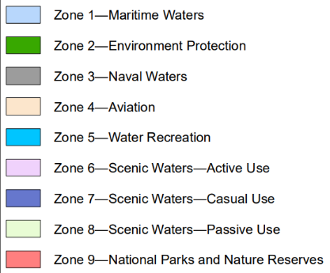
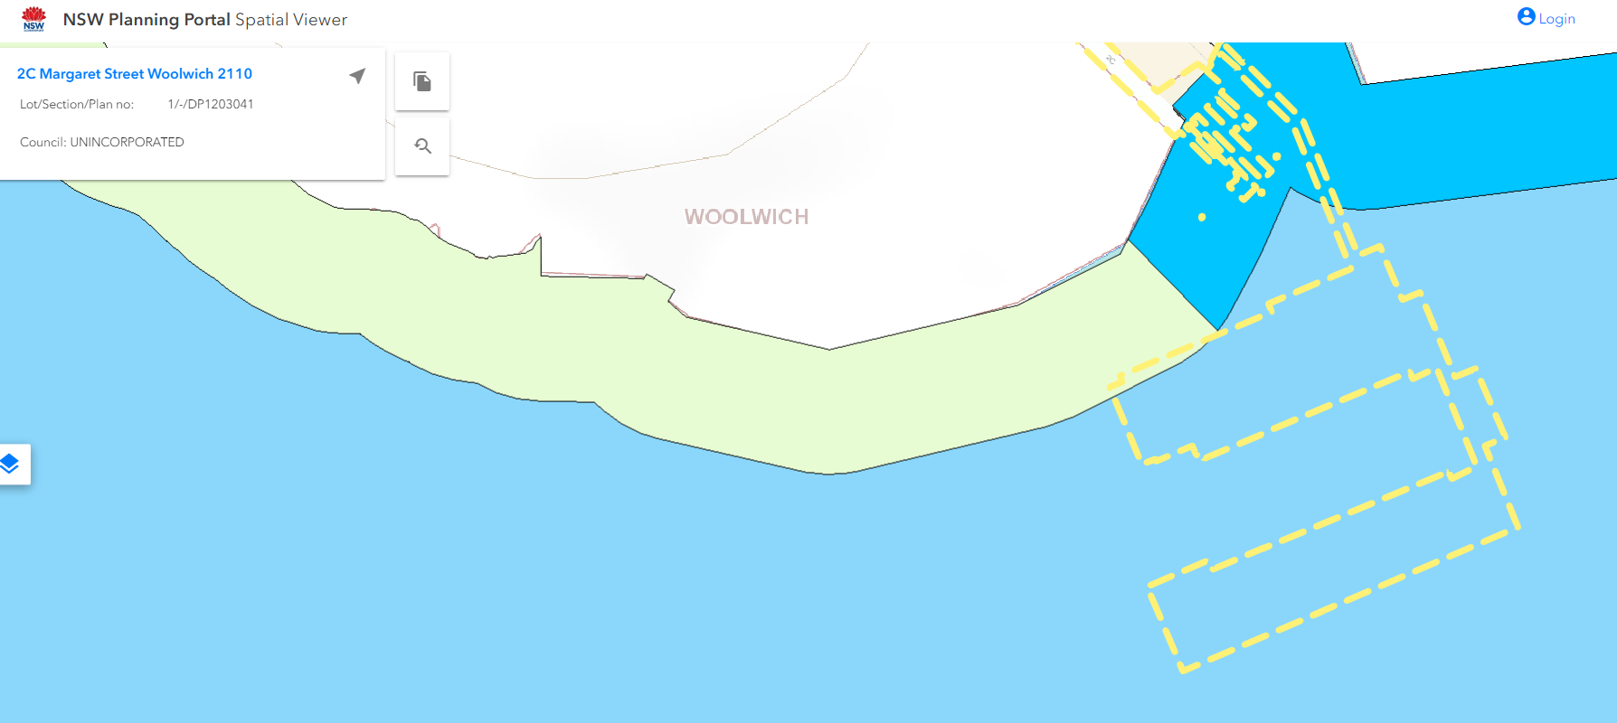
SOURCE: NSW PLANNING PORTAL 2024

FIGURE 13 – ZONING – LAND-BASED
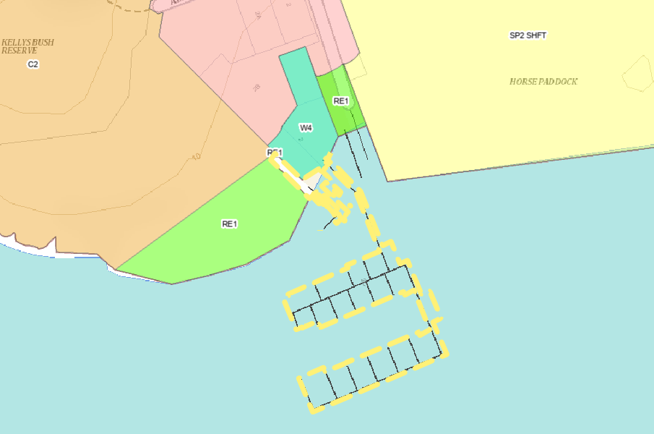
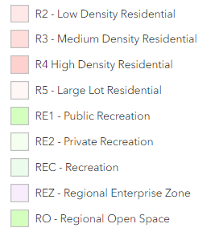
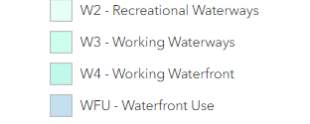
SOURCE: NSW PLANNING PORTAL 2024
- The proposal is permissible with consent in three of the four zones, but is expressly prohibited within Zone 8 – Scenic Waters – Passive Use.
- While the subject application does not propose to relocate swing moorings from or within the zone or undertake any construction activities within it, the mapping clearly shows Lot 1 in DP1203041 (the lease areas) partly within Zone 8. Council is of the view that the proposal will result in watercraft accessing berths 1-11 must traverse an even greater distance through the area mapped as Zone 8 and that such use is inconsistent with the zone objectives, as discussed below. The EIS fails to address the prohibition or provide appropriate justification.
- Figure 14 below provides an overlay of the proposal against the water-based zonings.

FIGURE 14 – OVERLAY OF THE PROPOSAL AND WATER-BASED ZONINGS
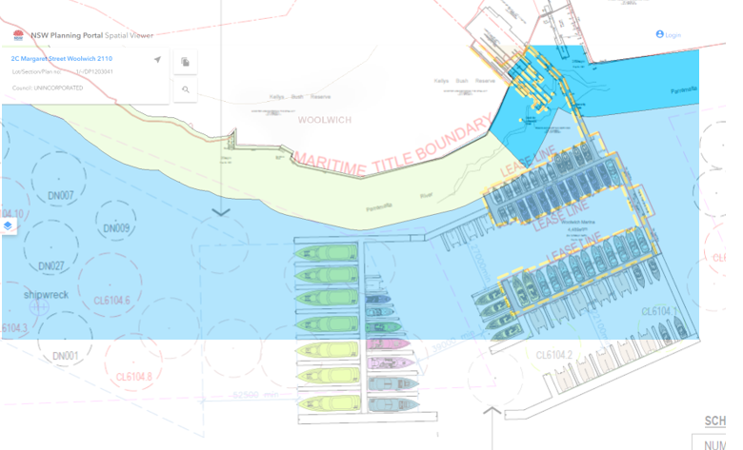
SOURCE: NSW PLANNING PORTAL 2024 AND DRAWING SK-02 PREPARED BY MICHEAL FOUNTAIN ARCHITECTS PTY LTD 2023
- The proposal is appropriately classified as Designated Development pursuant to Section 32, Schedule 3, Part 2 of the Environmental Planning and Assessment Regulation 2021.
- In terms of the declaration that the proposal is not Integrated Development, it is noted that the documentation has not provided any evidence of the input from the Department of Primary Industries - Fisheries or WaterNSW that confirms the proposal does not trigger approval under the Fisheries Management Act 1994 or the Water Management Act 2000.
- With respect to the EPBC Act, it is noted that DCCEEW have liaised with the applicant and considered the documents supplied under the “Self-Assessment” framework. DCCEEW advised the applicant by way of letter dated 27 October 2023 that:
“… the self-assessment does not include the following:
  - How the Cockatoo Island Management Plan has been considered (it is a legislative instrument under the EPBC Act), including Policy 15.
  - Confirmation that the proposed action will not enter or abut the buffer zone for Cockatoo Island (e.g. using clear imagery).
  - An adequate assessment of the visual impacts of the proposed action on views to and from Cockatoo Island in Appendix H – Visual Impact Assessment and Appendix B – Digital Photomontages.
  - An assessment of potential impacts against the Commonwealth Significant Impact Guidelines 1.1 – Matters of National Environmental Significance and Significant Impact Guidelines 1.2 – Action on, or impacting upon, Commonwealth land and Actions by Commonwealth Agencies.
The department recommends that a more robust EPBC Act self-assessment for the proposed action is undertaken against relevant Commonwealth requirements, including the above. The department’s website has information on how to undertake an EPBC Act self-assessment, including:
• Self-assessment before making a referral under the EPBC Act – DCCEEW
• Step-by-step guide to the referral and assessment process - DCCEEW (Step 2)
To ensure a robust EPBC Act self-assessment, the department recommends including suitable evidence to support the commitments (e.g. avoidance, mitigation and management measures) and conclusions made in the self-assessment. This could include heritage impact assessments, expert advice, state government approvals/permits, etc. It should also include consideration of a Protected Matters Search Tool report, relevant departmental information (e.g. Australian Heritage Database), guidelines (Significant Impact Guidelines 1.1 and 1.2), statutory documents and policies (e.g. Policy Statement – Definition of ‘Environment’ under section 528 of the EPBC Act).”
It is also understood that the applicant provided amended documentation to the Department, which DCCEEW reviewed, prompting advice to the applicant on 18 January 2024 that further refinements to their documentation would be necessary. It is understood the applicant gave an undertaking to the Department to prepare the amendments, however to date, the applicant has not submitted any revised documentation to Council or DCCEEW.
- Notwithstanding this, it is considered that the applicant has failed to adequately consider the potential visual impacts of the proposal on the setting and significance of the Woolwich Docks, in particular the Horse Paddock, which are listed as being of Commonwealth Significance and a World Heritage Property. Accordingly, Council is of the view that the self-assessment to determine whether the proposal will affect the Matters of National Environmental Significance is flawed and cannot be relied upon to demonstrate approval under the EPBC Act is not required.

- S.4.15 ENVIRONMENTAL PLANNING AND ASSESSMENT ACT 1979 – ASSESSMENT:
The relevant matters for consideration under section 4.15 of the Environmental Planning and Assessment Act 1979 are assessed under the following headings. Where a provision is not relevant to the proposal, it has been omitted from this report.

ENVIRONMENTAL PLANNING INSTRUMENTS (s. 4.15(1)(a)(i))
The proposal has been assessed against the relevant provisions of the applicable Environmental Planning Instruments in Table 1 below:
TABLE 1 - STATE ENVIRONMENTAL PLANNING POLICIES (SEPPS):
SEPP (Biodiversity and Conservation) 2021 (BC SEPP)
RELEVANT PROVISION | COMMENT: | COMPLIANCE:
Chapter 6 – Water Catchments
Part 6.2 – Development in Regulated Catchments | Located within the Sydney Harbour Catchment.  The proposal has not adequately demonstrated that the cumulative impact of additional boats to be berthed at the Site, the potential for fuel and chemical spills and cleaning of the vessels will not result in adverse impacts on:  - Water quality and quantity  - Aquatic ecology  The proposal is also adjacent to land zoned for recreation, of which significant value is associated with the outlook over the waterway, capturing the views of significant heritage-listed places such as Woolwich Docks and Parkland (including the Horse Paddock) and Cockatoo Island.  Further, the proposal will force boats within berths 1-11 to intrude within that part of the adjacent waterway, which is within Zone 8 – Scenic Waters – Passive Use. The proposed marina extensions, including the intensification of the swing mooring field, will result in restricted access to and around the foreshore with a landuse that is explicitly prohibited within Zone 8.  With respect to the specific provisions for marinas in Section 6.18, it is noted that the applicant has failed to provide the Archaeological Assessment and a Maritime Archaeology Study requested by Heritage NSW with respect to the known shipwreck within the area to be occupied by the proposal and as such, the Panel cannot be satisfied that the proposal will not result in the disturbance of the shipwreck and other artefacts or the marine sediments that form part of the bed of the waterbody. | YES ☐  NO ☒  N/A ☐
Part 6.3 Foreshores and Waterway Area – Zoning of Foreshores and Waterways Area | As discussed above, the water-based component of the Site is zoned as Zone 1 – Maritime Waters, Zone 5 – Water Recreation and importantly, Zone 8 -Scenic Waters – Passive Use.  In terms of being consistent with the objectives of each particular zone, the proposal in its current form is not considered to be appropriate, as follows:  Zone 1 – Maritime Waters:  The proposal will result in significant additional congestion and risk to users of the waterway through the replacement of an existing swing mooring field with a rigid pontoon. This will prevent smaller craft from utilizing the area occupied by the development in instances where conditions or the potential for conflict within the main channel of the waterway requires those craft to enter the mooring field. The effective privatization and enclosure of a large section of public waterway for private gain and use does not promote the equitable use of the Foreshores and Waterways Area, including use by passive recreation craft.  Zone 5 – Water Recreation:  The proposal will prevent public access by alienating a large section of public waterway and does not:  - Give preference to or increase public water-dependent development that will promote the enjoyment of, and free access to, the Foreshores and Waterways Area.  - Allow development that will enhance public use of waters in the zone and will compromise public use of waters in the zone in the present or future by entering into a long-term lease arrangement.  - minimise the number, scale and extent of artificial structures as a significant amount of piles will be needed to be driven into the bed of the waterway with additional pontoons required that will need significant engineering to overcome local wave, wash and tidal influences.  - The proposal does not adequately demonstrate there is a justifiable demand for the proposal by reference to measurable data. Instead, the proposal relies on tying the additional berths to broad targets identified in the Regional Boating Plan - Sydney Harbour Region and the Sydney Harbour Boat Storage Strategy 2013, both documents being over 5 years old.  - The benefits the proposal will tangibly generate to the general and boating public have not been identified or quantified.  - The proposal will have an adverse visual impact that is significantly incompatible with the character of the locality, including the significant relationship between the surrounding Heritage Items and their physical and visual link to the water and foreshore.  - The proposal has not demonstrated that it will not have a significant impact on the use of the surrounding waterways by other recreational users with respect to congestion and potential for conflict between waterway users, particularly given the number of sailing clubs that utilise the area to be occupied and adjacent both formally and informally. The proposal relies on a limited assessment by Transport for NSW which is has a limited focus on the pontoon structure itself and not the consequential impacts it will have on other watercraft. Furthermore, Transport for NSW had confirmed that no consideration has been given to the vast range of issues raised first-hand by long-standing sailing clubs and their members who could be reasonably expected to hold significant knowledge of local conditions.  - The vessels using the proposal will be of a size, height, bulk and scale that will adversely impact and restrict important views and vistas over the waterway. The scale and size of the intended watercraft are such that it will adversely affect the natural, cultural and scenic quality of the adjoining coastline, particularly when viewed from waters in the zone or from areas of public access such as the extensive open space areas surrounding the Site.  Zone 8 -Scenic Waters – Passive Use:  - The proposal fails to recognise the relationship between Kellys Bush and the unimpeded views over and connecting with the waterway and other important heritage sites nearby. It will not facilitate unimpeded public access along the intertidal zone by virtue of the intrusion of the existing marina into the zone or the enforced use of the zone by boats needing to access berths 1-11, or through the intensification of the swing mooring field.  - As previously stated, the proposal fails to demonstrate an actual demand for the development or that the size of the development is compatible with the locality.  - The applicant has failed to identify the existing development is located within a zone that it is expressly prohibited in. | YES ☐  NO ☒  N/A ☐
6.28 – General | The proposal will alienate a large tract of public waterway by encapsulating it in a marina in which people must pay to berth in. This, is directly in conflict with the following principles:  (i) Sydney Harbour is a public resource, owned by the public, to be protected for the public good,  (ii) the public good has precedence over the private good,  (iii) the protection of the natural assets of Sydney Harbour has precedence over all other interests.  The proposal will also prevent the equitable use of the Foreshores and Waterways Area as it will exclude passive recreation craft from an area and force those craft that normally traverse through here into the main navigational channel.  The development will have an adverse impact on the Foreshores and Waterways Area, particularly recreational uses through the physical exclusion of users, as well as the visual intrusion. | YES ☐  NO ☒  N/A ☐
6.32 - Rocky Foreshores and Significant Seagrasses | Although the existing marina is located within a mapped area, the proposal includes works that involve relocating at least one swing mooring within a mapped area. Refer to composite sketch provided in Figure 15 below.  The EIS does not address this aspect of the proposal or identify what works will physically occur in the act of relocating the mooring identified in the sketch below. The Marine Habitat Survey prepared by Bio-analysis Pty Ltd notes that one species of seagrass exists in close proximity to the existing slipways.  The Survey also notes that limited field surveys involved “Underwater transects were run along the seabed parallel to the existing marina and in the footprint of the proposed development.” These transects were not recorded or mapped and there is no conclusive evidence that the Study assessed the particular mooring to be relocated or in fact the area where all of the moorings are to be relocated as to whether it contained a rocky foreshore and associated ecological community.  Accordingly, the Panel cannot be satisfied that the development has adequately met the provisions of Section 6.32 in relation to either seagrasses or the rocky foreshores. | YES ☐  NO ☒  N/A ☐
FIGURE 15 – OVERLAY OF THE PROPOSAL AND ROCKY FORESHORES MAP OVERLAY
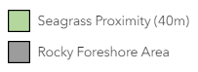
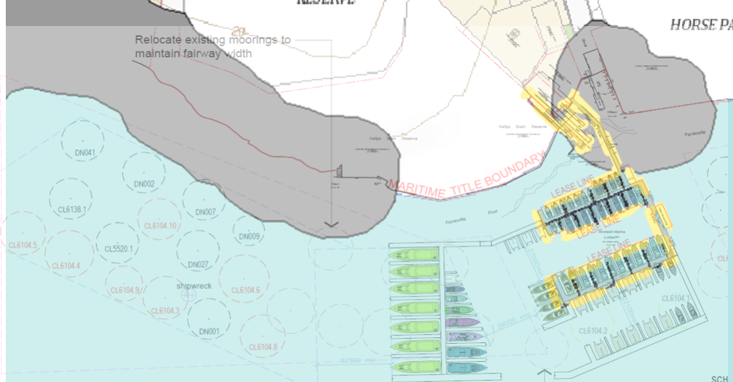
Part 6.4 – Heritage Conservation in Sydney Harbour | Although the Site is not identified as a mapped Heritage Item, Heritage NSW have requested the applicant provide an Archaeological Assessment and a Maritime Archaeology Study given the identified failings of the Statement of Heritage Impact, the proximity to one of the oldest suburbs in Australia and a known shipwreck.  It should also be noted that the SEARs clearly state that the EIS must include a historical and maritime archaeological assessment where a potential impact on historical and maritime archaeology. The rationale behind this is to ensure the EIS can be based on accurate and complete information. That such documents have not been prepared, it is not unreasonable to question whether the EIS provides a balanced and informed assessment to the Panel.  According to an AHIMS search undertaken by the author of this report, there is at least one known Aboriginal Site within 200m of the proposal. This is not addressed in any detail in either the EIS or the Statement of Heritage Impact.  Until such time as the requested information has been provided and demonstrates the area where the proposal and its associated works will occur do not contain Aboriginal or European relics etc, the Panel cannot be satisfied that the proposal will have an acceptable impact on the heritage values of the development area and its surrounds. Equally concerning is the failure to demonstrate engagement has occurred with the Metropolitan Aboriginal Land Council. | YES ☐  NO ☒  N/A ☐
SEPP (Resilience and Hazards) 2021 (RH SEPP)
RELEVANT PROVISION | COMMENT: | COMPLIANCE:
Chapter 2 – Coastal Management | The Site mapped as being within the Coastal Environment Area and Coastal Use Area, as per the map extracts below.  The Coastal Environment Area:  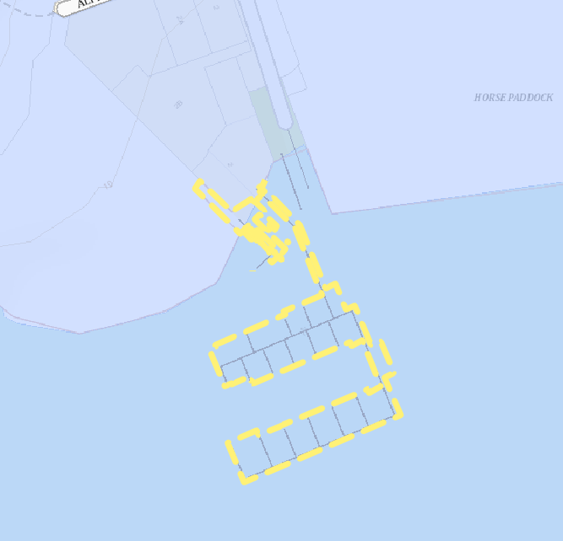  The Coastal Use Area:  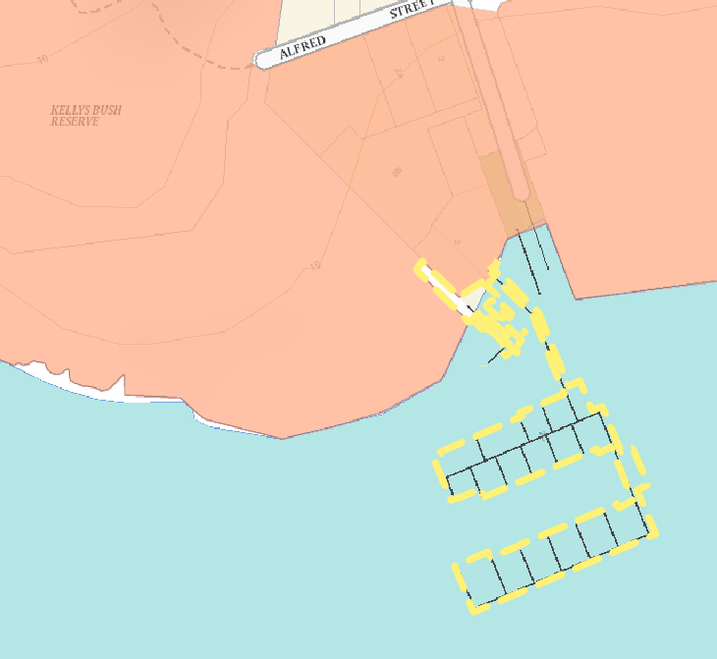  The EIS fails to undertake an assessment of the proposed land-based elements of the proposal (i.e. intensification of car parking spaces) in the context of the matters contained within Section 2.10(1) and 2.11(1). Further, it fails to demonstrate how the proposal – in particular the management of waste, the containment of spills, regular cleaning of the decks of boats or the provision of access along the foreshore adjacent to the proposed northern arm, will be undertaken in a way that mitigates the potential impacts of the development. | YES ☐  NO ☒  N/A ☐
Chapter 4 – Contamination of Land | Pursuant to Clause 4.6(1), the Consent Authority must consider whether the land is contaminated and if so, whether it can be suitably remediated. Given the application proposes to change the use of the site (in part) from an open waterway to a marina and it lies adjacent to an existing marina slipways and boat repair facilities where there has been a history of servicing boats, it is appropriate to consider the findings of a Preliminary Environmental Site Assessment.  The submitted Water Quality and Sediment Assessment prepared by Advisian identified elevated levels of arsenic, copper, lead, zinc, C10-C40 fraction hydrocarbons all above relevant guidelines. Contrary to the statement made on p. 33 of the EIS, the assessment does not make any conclusions as to whether the Site is contaminated, if remediation is required or if the Site is suitable for the proposed development.  Further, in the event that remediation is required, a Detailed Environmental Site Assessment to further characterise the Site, as well as the preparation of a remediation action plan. However, without any actual conclusions capable of being drawn from the material presented, the Panel cannot be satisfied that the issue of contamination has been sufficiently resolved. | YES ☐  NO ☒  N/A ☐
REGIONAL ENVIRONMENTAL PLANS (REPS) – DEEMED SEPPS – N/A
TABLE 2 – HUNTERS HILL LOCAL ENVIRONMENTAL PLAN 2012:
1.2 Aims of Plan | Having regard to the nature of the proposal and the supporting documents, it is considered that the proposal fails to satisfy the following aims of the Plan.  (a) to maintain and enhance the character and identity of established neighbourhoods in Hunters Hill by regulating the use and development of land,  Comment:  The relationship between the established residential neighbourhoods of the LGA and the views over the respective waterways are an intrinsic element of the local character. Kellys Bush was saved from development to ensure that the historic connecting vista with Cockatoo Island.  (b) to maintain and enhance biodiversity values by conserving natural features and scenic qualities that distinguish the municipality,  Comment:  The proposal will result in a significant, visually intrusive element in front of Kellys Bush that will adversely affect views of Kellys Bush and the foreshore from other places within the public domain as well as from Kellys Bush and the surrounding parkland across the waterway towards Cockatoo and Spectacle Island, to the point that the scenic qualities of the reserve and the high- value and intrinsic relationship between Kellys Bush, the foreshore, the harbour and Cockatoo and Spectacle Islands will be adversely impacted.  (c) to conserve Aboriginal heritage and European heritage that influence the character and identity of the municipality,  Comment:  The proposal has not demonstrated that the required engagement with the Metropolitan Aboriginal Land Council has been undertaken or that little more than a cursory search of AHIMS has been undertaken to establish the proposal is unlikely to have impacts on Aboriginal cultural heritage and sites. The comments provided by Heritage NSW and in particular the request to provide an archaeological assessment, a maritime archaeology study and a revised desktop study and HIS with input from a qualified and experienced maritime archaeologist demonstrates that the proposal has not provided sufficient information to enable the Panel to be satisfied the development will not have an adverse impact on heritage values in the surrounding area.  (g) to maintain a network of open spaces that conserve natural and scenic qualities, as well as providing a variety of active and passive recreation opportunities for residents of the municipality and surrounding areas,  Comment:  The waterway itself provides both active and passive recreation opportunities and the alienation of such a large tract of the water to be occupied by a number of large boats whose scale, height and size will impact on the views and vistas of and from the large tracts of open space areas surrounding the Site. | YES ☐  NO ☒  N/A ☐
2.1 Zoning | The land-based components are zoned W4 – Working Waterfront. The alterations to the car parking layout are deemed to be ancillary to the marina and no objection is raised in this regard. | YES ☒  NO ☐  N/A ☐
2.3 Zoning Objectives | The rearrangement of the car parking is not inconsistent with the zone objectives. | YES ☒  NO ☐  N/A ☐
5.10 Heritage Conservation | Is the Site a heritage item/ Conservation Area?  YES ☒ NO ☐  Item ☐ HCA ☒  The proposal is not supported by Council’s Conservation Advisory Panel or Heritage Consultant, nor by Heritage NSW. The Sydney Harbour Federation Trust, the Hunters Hill Trust and Friends of Kelly Bush have also raised concerns with or objected to the proposal. All have identified the failure of the proposal and its associated studies to adequately address the heritage significance and values of the surrounding Heritage Conservation Area, Kelly’s Bush as a State Heritage Item, the Woolwich Docks and Parklands which includes the Horse Paddock as Commonwealth Heritage Places and Cockatoo and Spectacle Islands as National and UNESCO-listed item. Central to the proposal’s failure is the lack of comprehension of the significance of the setting, the visual connection to and of these places and the resultant visual intrusion and impact the proposal will create.  The application has also failed to address the maritime archaeological assessments requested by Heritage NSW and has given little regard to the clear links between Aboriginal people and the surrounding area. To date there has been no demonstration of engagement with the Metropolitan Aboriginal Land Council.  Given the above and the assessment provided elsewhere in this report, the proposal is considered to be inconsistent with the stated objectives to conserve:  (a) the environmental heritage of Hunters Hill,  (b) the heritage significance of heritage items and heritage conservation areas, including associated fabric, settings and views,  (c) archaeological sites,  (d) Aboriginal objects and Aboriginal places of heritage significance.  The lack of adequate information to inform the EIS and failure to demonstrate engagement with the Metropolitan Aboriginal Land Council could not lead the Panel to be satisfied the proposal is consistent with the objectives of the clause. | YES ☐  NO ☒  N/A ☐
6.1 Acid Sulfate Soils | Class 5 land located within 100m of class 2 land. | YES ☒  NO ☐  N/A ☐
6.2 Earthworks | No earthworks within the land-based component. | YES ☐  NO ☐  N/A ☒
6.3 Stormwater Management | Existing hardstand and no physical works proposed. | YES ☒  NO ☐  N/A ☐
6.4 Terrestrial Biodiversity | Will any land mapped biodiversity be affected?  YES ☐ NO ☒ | YES ☐  NO ☐  N/A ☒
6.5 Riparian Land and Adjoining Waterways | The Site is not within a mapped riparian area. | YES ☐  NO ☐  N/A ☒
6.6 Limited Development on Foreshore Area | Will any land mapped as foreshore be affected?  YES ☒ NO ☐  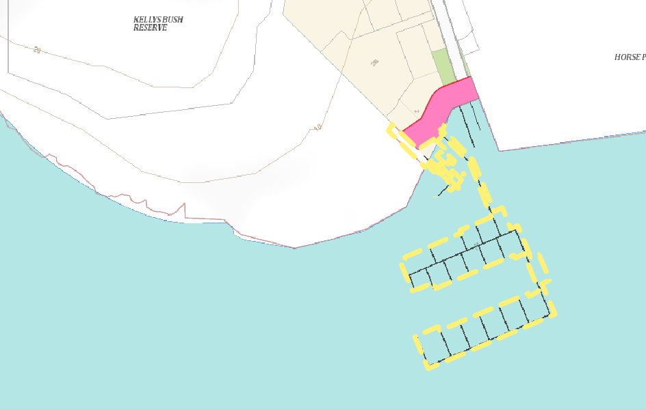  Is the proposal a purpose listed in Subclause 2?  YES ☐ NO ☒  While not specifically identified, the rearranged car parking layout to increase the number of vehicles parked on the Site will not be in conflict with the foreshore as it is already existing. | YES ☒  NO ☐  N/A ☐
6.7 Development on River Front Areas | Will any land mapped as river front area be affected?  YES ☒ NO ☐ N/A ☐  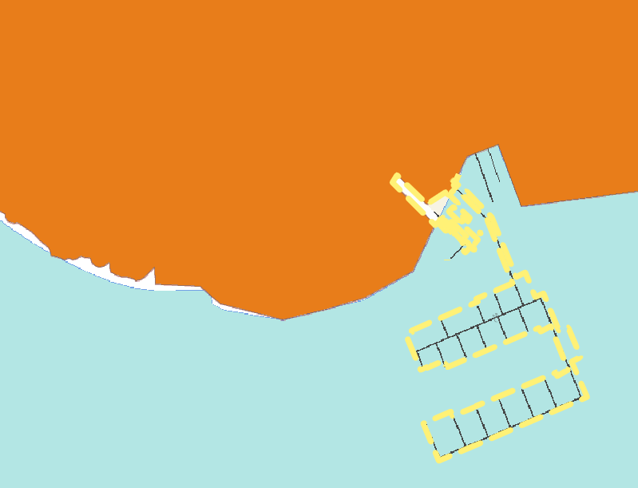Are the works acceptable in terms of Subclause 3 matters? Yes – the proposed car parking is existing and relatively screened from the foreshore. | YES ☒  NO ☐  N/A ☐

DRAFT EPIs (s. 4.15(1)(a)(ii)) YES ☐ NO ☐ N/A ☒

DEVELOPMENT CONTROL PLAN (s. 4.15(1)(a)(iii))
Overview and General Comment:
From a statutory perspective, while not holding the same power of an LEP or SEPP, a DCP has an important role to play in the assessment and determination of a development application. DCP’s provide the guidance and controls necessary to effect the aims of the SEPPs and LEPs, they facilitate permissible development by helping to shape the space in which that development can be undertaken in a manner that ideally, will not cause adverse impacts, and they seek to fulfill the particular objectives of each zone.
In this instance, there are two DCPs that apply - the Hunters Hill Development Control Plan 2013 (HHDCP) and the Sydney Harbour Foreshore and Waterways Area Development Control Plan 2005 (SHFWDCP). The HHDCP is applicable as it gives effect to the provisions of the HHLEP, the other because it gives effect to the BC SEPP. It is of particular concern then that the EIS clearly states that “The Hunters Hill Development Control Plan 2013 does not provide for any specific controls relating to marinas or water related structures.”
The HHDCP may not have specific marina-related controls, but it does have provisions that are relevant to assessment of all development applications. These provisions apply to the proposal because such a development does operate in isolation to the land upon which it connects to or the context upon which it is within. The land-based implications for a development such as this include the potential for impacts on the availability of parking in an area, the capacity of the local road network, or the way in which the Site interacts with surrounding properties in the context of amenity impacts such as noise, views, privacy and the ability to move about in the local area. That the EIS has made the statement above regarding the HHDCP, further reinforces the view that the proposal in its current form is unable to demonstrate a thorough and adequate assessment has been undertaken and that it has sufficient merit or information to warrant approval.
An assessment of the relevant DCP provisions is provided in Tables 3 and 4 below.
With respect to the SHFWDCP, it is noted that the aim of the performance-based criteria and guidelines seek to:
  - Protect ecological communities.
  - Ensure the scenic quality of the area is protected or enhanced.
  - Provide siting and design principles for new buildings and waterside structures.
  - Identify potential foreshore access locations in the area.
These go hand in hand with the overall planning principles that were developed for the Foreshores and Waterway Area, which are addressed in Table 5 below.

TABLE 3 – COMPLIANCE ASSESSMENT - HUNTERS HILL CONSOLIDATED DEVELOPMENT CONTROL PLAN 2013 (HHDCP):
RELEVANT PROVISION | COMMENT: | COMPLIANCE:
Part 1 – Introduction
1.3 Aims and Objectives | The proposal fails to satisfy the following Strategic Objectives:  (i) To maintain and enhance the character and identity of established neighbourhoods in the Hunters Hill Municipality.  (ii) To maintain and enhance biodiversity values by conserving natural features and scenic qualities that distinguish this Municipality.  (iii) To conserve identified heritage values that influence the character and identity of this Municipality.  (v) To specify services that are necessary for each development, which include car parking and water cycle management.  The proposal’s adverse impacts on the character of the area, conservation of the scenic qualities of the landscape and harbour, conservation of important heritage views, vistas, landscapes and the relationships between places and the Harbour and visual impacts have been addressed previously. Further comment with respect to car parking will be provided further below. | YES ☐  NO ☒  N/A ☐
Part 2 – Character and Heritage
2.2.2 – Aims and Objectives | The proposal is inconsistent with the following aims and objectives:  (a) Conserve and enhance character and environmental identity of the Hunters Hill Municipality by the appropriate use and development of land, existing buildings and structures.  (b) Maintain and enhance qualities of existing buildings and structures, tree covered streetscapes and scenically prominent landscape settings which are important elements of this Municipality’s heritage, scenic quality and environmental identity.  As stated above, the proposal will have adverse impacts on the character of the area, conservation of the scenic qualities of the landscape and harbour, conservation of important heritage views, vistas, landscapes and the relationships between places and the Harbour and visual impacts. | YES ☐  NO ☒  N/A ☐
2.2.3 – Existing Character | Refer to comments from the Conservation Panel and Council’s Heritage Advisor, as well as Heritage NSW. | YES ☐  NO ☒  N/A ☐
2.2.4 – Desired Character | Refer to comments from CAP and Heritage Advisor.  The proposal will not contribute to the existing natural character and prominent views to and between the identified heritage items. It will visually dominate the surrounding foreshore and waterway when viewed from both nearby private properties and many points within the foreshore reserves, surrounding roadways and heritage places such as the Horse Paddock and the Kelly’s Bush lookout. The proposal will also result in an undesirable impact on the outlook from Kellys Bush and the Horse Paddock to Cockatoo and Spectacle Islands.  It is important to note that at the core of the public campaign to save Kelly’s Bush – the world’s first “Green Ban” and to prevent the Woolwich Dock from being redeveloped for high density housing was an overriding demand to retain these spaces forever in the hands of the community so that not just the land, but their uninterrupted views over the harbour to Cockatoo and Spectacle Islands could also be protected and retained for the betterment and welfare of the community. | YES ☐  NO ☒  N/A ☐
2.4.2 – Aims and Objectives – Heritage and Conservation | As demonstrated previously, the proposal has not provided sufficient information to demonstrate that it will not have a significant adverse impact on the surrounding heritage items and Conservation Area. The proposal is inconsistent with the stated aims and objectives and has not satisfied either Council or Heritage NSW’s concerns with respect to missing information or and veracity of the assessment. | YES ☐  NO ☒  N/A ☐
2.4.4 – Detailed Requirements for Heritage Items | As above and as per the comments provided by Heritage NSW, CAP and Council’s Heritage Advisor. | YES ☐  NO ☒  N/A ☐
2.4.5 – Detailed Requirements for Heritage Conservation Areas | As above and as per the comments provided by Heritage NSW, CAP and Council’s Heritage Advisor. | YES ☐  NO ☒  N/A ☐
2.4.6 – Assessment Procedures for Heritage Conservation | As above and as per the comments provided by Heritage NSW, CAP and Council’s Heritage Advisor. | YES ☐  NO ☒  N/A ☐

TABLE 4 – COMPLIANCE ASSESSMENT - SYDNEY HARBOUR FORESHORE AND WATERWAYS AREA DEVELOPMENT CONTROL PLAN 2013 (HHDCP):
RELEVANT PROVISION | COMMENT:
Section 2 - Ecological Assessment: | The Site is mapped as containing both Grassland Terrestrial Ecological Community and Mixed Rocky Intertidal and Sand Aquatic Ecological Community. The Ecological Communities of Kelly’s Bush to the west are mapped as Open Forest (Type B)/ Mixed Rocky Intertidal and Sand Aquatic, while the Horse Paddock to the east of the Site is mapped the same as the subject Site.  While the Grassland community is listed as having a “Low Conservation Status” in Table 1 of the DCP, the Open Forest and Mixed Ecological Communities have a “High Conservation Status”.  Table 5 of the DCP then establishes the Intentions and Performance Criteria for Aquatic Ecological Communities of High Conservation Value and the applicant has prepared an assessment against these provisions in Table 11 of the EIS.  In terms of that assessment, it is noted that the EIS states under the criteria of “Physical Damage” that the proposal will not cause any damage to identified seagrasses and the like. As noted previously, the Marine Habitat Survey has not documented exactly what areas have been surveyed and does not address any works required to remove or relocate the swing moorings. Accordingly, the EIS fails to demonstrate there will be no adverse impacts on the Mixed Rocky Intertidal and Sand Aquatic Ecological Community.
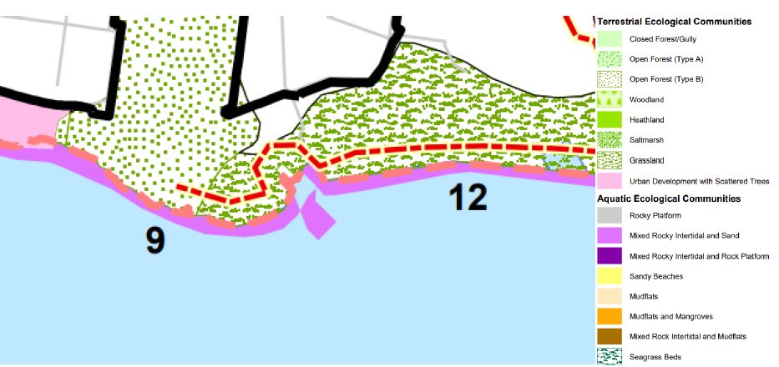
Section 3 – Landscape Assessment | As noted in Section 3.1 of the DCP, a consent authority must consider the visual impact of development from the waterway and foreshores. It notes that the degree of visual impact will depend on factors such as:  - The nature of the proposal - its height, width, siting, scale, colour, reflectivity and function.  - The landscape setting in which it is proposed.  - The degree of change created - whether it will be minimal or not.  - The ability of the proposal to integrate with the landscape character.  Having regard to the factors above and the stated aims in Section 3.2, the development, when operating as proposed:  - Will be of a size, scale and appearance that it will significantly impact on the vistas and views to and from the heritage-listed Kelly’s Bush and the Horse Paddock and severely disrupt their visual connection with the Habour and Cockatoo and Spectacle Islands.  - Will be of a size and scale that does not complement the natural bushland setting of Kelly’s Bush or scenic character of the area.  - Will have a significant visual impact on the foreshore of Kelly’s Bush or the Horse Paddock, both of which are distinctive visual features when viewed from the waterway and likewise, disrupt the visual connection between these places and Cockatoo and Spectacle Island.  - Will not have a positive impact on the relatively homogeneous landscape character.  In this regard, the Site and Kelly’s Bush are within Landscape Character Type 9, while the Horse Paddock is within Landscape Character Type 15. The proposal is assessed against the Intent and Performance Criteria of each Character Type below:
Landscape Character Type 9: | The proposal is inconsistent with the Statement of Intent to retain the natural features dominated by Kelly’s Bush and is of a scale, when operating as proposed that is inconsistent with the scale, design and siting of the existing marina.  The proposal is also inconsistent with the Performance Criteria as follows:  - it is designed, sited and will operate in a manner that the vegetated shorelines of Kelly’s Bush and stone sea walls of the foreshore park and the Horse Paddock will be obscured from various points on the waterway and Cockatoo and Spectacle Islands.  - it is designed, sited and will operate in a manner that the stone sea walls of the foreshore park and the Horse Paddock will be obscured from various points on the waterway and Cockatoo and Spectacle Islands.  - The proposal will compromise the ability to see and interpret the foreshore and bushland of Kelly’s Bush from the water and Cockatoo and Spectacle Islands.  - The proposal will see the arms of the marina extend in front of Kelly’s Bush and result in an increased density of boats within the swing mooring field, detracting significantly from the natural bushland character. The disruption of the visual link from and to Kelly’s Bush by the marina will cause significant loss of heritage value and will diminish the significance of the intertwined natural and social relationship with the water and other noted heritage items.  - The vessels berthed within the development will largely be white, which will not match the backdrop of the bushland in Kelly’s Bush.
Landscape Character Type 15: | The EIS does not provide any assessment against this Landscape Character Type, which fronts the Horse Paddock foreshore. While this typology reflects a higher level of urban development in the backdrop, in this case it is the Woolwich Docks and Parklands. This significantly contains the cleared open space of the Horse Paddock.  The proposal is inconsistent with the Performance Criteria as follows:  - The marina is deemed to be a commercial activity as opposed to industrial as it essentially stores the boats it is intended to hold as opposed to manufactures them.  - The lack of adequate car parking to serve the anticipated demand will have flow-on effects for the parking within the Docklands.  - it is designed, sited and will operate in a manner that the stone sea walls of the foreshore park and the Horse Paddock will be obscured from various points on the waterway and Cockatoo and Spectacle Islands.
Section 4 – Design Guidelines for Water-based and Land/ Water Interface Developments
4.2 – General Requirements | The proposal is not consistent with the following general requirements:  - The proposal will alienate public access to a large area of the waterway and the design of the arms are not conducive to the public utilizing the waters between the arm closest to shore and the shoreline. The extension out into the main channel will also act as a deterrent to small watercraft if faced with the prospect of entering or maneuvering within it and competing with faster and larger vessels.  - The size and physical proportions will have a significant narrowing of the available water within which craft could navigate or traverse through, thus forcing a potentially a large number of smaller watercraft for example into a smaller channel where they are face the risk of impeding larger vessels.  - Anecdotal evidence from experienced members of the sailing community indicates have raised a number of concerns with the assessment provided in the EIS, particularly relating to navigational safety and congestion of the waterway.  - The size and spatial extent of the development prevents smaller craft from using the existing mooring field as an “escape” for smaller vessels to traverse the relatively narrow channel. It will also alienate a larger area of public waterway for private use.  - The applicant has not provided any quantifiable justification for the proposal and relies on a vague connection to the harbour-wide strategies to increase boat storage that date back some years.  - The size and spatial extent of the development when operating will result in a significantly adverse impact on the landscaped setting.
4.3 – Foreshore Access | As discussed previously, the extension of the development across the foreshore will inhibit access to the foreshore due to its spatial dimensions and proximity to the shoreline.
4.4 – Siting of Buildings and Structures | As noted previously, the existing marina is sited over land in Zone 8 and access to berths 1-11 results in vessels having to go through an area intended to exclude the marina. The structure will mean that people using those berths will have to traverse Zone 8 for a much longer distance. Further, one of the proposed swing moorings appears to be over a known shipwreck however there has been insufficient assessment of that action or information to quantify the impacts. The submitted Marine Habitat study also fails to clearly show where underwater transects actually occurred and consequently, cannot demonstrate that
4.7 – Marinas:  Location | The proposal is inconsistent with the following objective and guiding principles:  - marinas are not to reduce the number of publicly available single (swing) moorings, jeopardise safe navigation or adversely impact other water users including small craft; and  - waterside structures are to minimise impacts on public water activities.  As noted previously, the provision of the rigid marina arms will prevent small craft from using the existing swing mooring field as a means to take shelter from larger craft in the main channel. The marina will alienate a large tract of public waterway and preclude the public from using the area between the arm and the foreshore.
Design and Layout | The proposal is inconsistent with the following objective and guiding principle:  - the extent of development over water including waterside structures, berths, fairways and access channels is to be minimised and result in minimal alienation of the waterway.  The development in its entirety will alienate a significant portion of the waterway from use by the public. Public access and use of the waterway is a fundamental principle of the DCP, which has been consistently upheld by the NSW Land and Environment Court.
Facilities and Services | The proposal is inconsistent with the following objective and guiding principles:  - commercial marinas are to provide a mix and choice of boat storage facilities based on established demand as well as a range of marine services to the boating public.  - commercial marinas are to provide benefits to both the general and boating public.  The EIS does not provide any quantification of the actual demand either for additional marina berths of particular sizes or types of berths. While the EIS refers to the 2015 Transport for NSW Regional Boating Plan in Section 2.3, the numbers quoted are vague, cannot be attributed to the Site or surrounding and appear to be different to the 2022 edition of the Regional Boating Plan, the numbers quoted appear somewhat differently. Likewise, it does not quantify any benefits to the general public, other than to state that it will “continue to provide benefits to the broader public, by enhancing community use and access to the harbour foreshore”.
Visual Impact | The proposal is inconsistent with the following objective and guiding principles:  - The visual contrast (derived from an analysis of form, line, colour and texture) between the marina and the existing or planned future character of its setting is to be minimised;  - The visual impact of the marina on people in the visual catchment (derived from an analysis of the potential number of viewers, their location within the landscape, distance from the marina, and duration of view) is to be minimised;  - Any visual analysis shall consider the impact of the largest motor vessel(s) capable of being berthed at the marina;  - The largest vessels (motorised or otherwise) to be berthed at the marina are to be located as far from shore as possible;  - Waterside structures and berthed vessels associated with marinas are not to block views from foreshore public open space or views to foreshore public open space from the waterway;  The documentation submitted with the application fails to adequately fulfill any of these principles with no visual contrast assessment undertaken. Additionally, the Visual Impact Assessments (VIAs) have not addressed the views, vistas and visual impacts from surrounding private properties or from the Woolwich Dock and Parklands, including various locations within the Horse Paddock, Morts Reserve or Clarkes Reserve, The Hunters Hill Sailing Club or Spectacle Island. The imagery used in the assessment appears narrow and selective and there has been no attempt to capture the potential impacts caused by increasing the density of the swing mooring field. Despite the statements in the May 2023 and November 2023 Supplement that the precedents established from Rose Bay Marina Pty Ltd v Woollahra Municipal Council (2013) and Tenacity Consulting Pty Ltd v Warringah Council (2003) had informed the VIAs, there is no evidence that the methodology development by the Court has actually been employed in determining the proposal will have no adverse visual impacts.  Furthermore, there is no evidence to support the claims in the VIAs that they have been …“based on the structure and guidelines established for Visual Impact Assessment of marinas in Sydney Harbour Foreshores and Waterways Area Development Control Plan (2005).” Appendix D of the SHFWA DCP outlines the steps involved in undertaking a visual impact assessment for marinas, however the VIA does not demonstrate how these provisions have been achieved.
Environmental Management | The proposal is inconsistent with the following objective and guiding principles:  Pollution and waste:  - The operational waste management plan contains few details on how practices such as regular washing of decks may contribute to pollution of the waterway.  - There is no strategy for dealing with the waste streams that will come off the larger vessels that are capable of holding large numbers of guests at the conclusion of a charter.  - There is no assessment as to whether the capacity or storage capacity of waste bins or frequency of collection will adequately meet the expected demand or whether the existing sewage pump out facilities have sufficient capacity to meet the planned demand.  Traffic and Parking:  - The plans and traffic assessment do not demonstrate that existing service vehicles (such as a medium rigid liquid waste removal truck) can access and service the Site.  - Table 3 of the Traffic and Parking Impact Assessment does not appear to reflect the correct scale of the proposed marina (for example, Table 3 quotes 60 vessels under 20 metres but the plans indicate 59 boats. Likewise there are 2 boats between 20m and 25m, as oppose to the stated 1. While the end change in demand may be quite superficial, it highlights a shortcomings in the traffic assessment.  - The Traffic assessment does not appear to take into account the potential for the larger boats to carry crew and passengers. While the assessment does apply the parking rates generally accepted by the Court, there is no assessment of the likely impacts of guests on joining or alighting from the boats.  - The Traffic assessment notes that the site currently has a shortfall of up to 19 spaces, however taking into account the proposal will result in an improvement slight reduction parking spaces existing shortfall.
Noise | The proposal is inconsistent with the following objective and guiding principle:  - the adverse impacts of noise (considering hours of operation, existing background noise, expected departure/arrival times for vessels, noise level of marina patrons, noise level from repair and testing of vessels and motors) are to be minimised through appropriate design and management measures.  The submitted Noise and Vibration Impact Assessment does not appear to take into account the various sizes of the additional vessels, which includes boats up to 35m in length, arriving and departing in peak times and periods. Boats of this size can contain a large number of people and operate in a commercial charter capacity. For example, the return of several 12m or 16m boats at the same time will have a markedly different noise profile to one or two of the larger boats returning from a weekend charter, disembarking crew and passengers.

TABLE 5 – COMPLIANCE ASSESSMENT - FORESHORES AND WATERWAYS PLANNING PRINCIPLES:
PRINCIPLE | COMMENT:
Development should protect, maintain and enhance the natural assets and unique environmental qualities of Sydney Harbour and its islands and foreshores. | The proposal will create adverse visual impacts on the surrounding foreshore land, which includes a number of State and Commonwealth-listed Heritage Items, whose intrinsic value relies upon the protection of those scenic qualities and visual connection that this proposal will ultimately have a significant adverse impact on.
Public access to and along the foreshore should be increased, maintained and improved, while minimising its impact on watercourses, wetlands, riparian lands and remnant vegetation. | Although public access through the land-based components of the subject Site is not sought or contemplated, the proposal will result in even longer movements of boats accessing berths 1-11 through the foreshore in Zone 8 -Scenic Waters – Passive Use, as identified above. It has already been established that the existing marina intrudes upon Zone 8 -Scenic Waters – Passive Use, in which a marina is explicitly listed as prohibited development.
Access to and from the waterways should be increased, maintained and improved for public recreational purposes (such as swimming, fishing and boating), while minimising its impact on watercourses, wetlands, riparian lands and remnant vegetation. | The proposal will alienate a large tract of public waterway by way of the design, size and placement of the additional pontoons, forcing users of berths 1-11 to traverse a greater distance through the foreshore in Zone 8 -Scenic Waters – Passive Use and the relocated swing moorings, which create greater density of vessels. As noted above, the application lacks sufficient adequate information to determine that the proposal will not have an adverse impact on the surrounding biophysical environment.
Development along the foreshore and waterways should maintain, protect and enhance the unique visual qualities of Sydney Harbour and its islands and foreshores. | The proposal will disrupt the important visual link between Kelly’s Bush and the Harbour, in particular Cockatoo and Spectacle Islands, as well as the views and vistas from these places and on the waterway itself back at Kelly’s Bush and the Woolwich Docklands.
Adequate provision should be made for the retention of foreshore land to meet existing and future demand for working harbour uses. | There is no strategic intent to expand the existing Working Harbour zoned land at the site.
Public access along foreshore land should be provided on land used for industrial or commercial maritime purposes where such access does not interfere with the use of the land for those purposes. | N/A
The use of foreshore land adjacent to land used for industrial or commercial maritime purposes should be compatible with those purposes. | The surrounding foreshore land is not incompatible with the commercial maritime purposes as it stands. The proposed expansion well beyond the “frontage” of that commercial maritime land will however be incompatible to the use of that land and its particular scenic and heritage values.
Water-based public transport (such as ferries) should be encouraged to link with land-based public transport (such as buses and trains) at appropriate public spaces along the waterfront. | N/A
The provision and use of public boating facilities along the waterfront should be encouraged. | The proposal is to expand an existing private over a public waterway and therefore inconsistent with this Principle.

PLANNING AGREEMENTS (s. 4.15(1)(a)(iiia)) YES ☐ NO ☐ N/A ☒

ENVIRONMENTAL PLANNING AND ASSESSMENT REGULATION 2021 (S. 4.15(1)(A)(IV)) YES ☐ NO ☐ N/A ☒

THE LIKELY IMPACTS OF THE DEVELOPMENT (s. 4.15(1)(b)(i))
The proposal has been assessed against the relevant matters for consideration under Section 4.15 of the Environmental Planning and Assessment Act 1979, the Hunters Hill Local Environmental Plan 2012, Hunters Hill Consolidated Development Control Plan 2013 and applicable State Environmental Planning Policies and associated guidelines. The impacts associated with this development have been identified through extensive field inspections of the Site and surrounding area, a review of the proposal against the applicable planning and environmental controls, formal comment and feedback by relevant stakeholders and a review of the submissions received as a consequence of the public exhibition period.
As demonstrated in this assessment the proposal’s core failure lies in the lack of adequate and complete documentation, including the early engagement and involvement of all relevant parties before compiling the EIS and the inability to understand the intrinsic link between the significance of the surrounding heritage-listed properties to the harbour and each other and the harbour to those properties. Further, the failure to understand and demonstrate the visual impact of the development also forms part of the resulting unacceptable planning outcomes this development will have. The application has not provided the Consent Authority with sufficient or adequate information to be satisfied that the proposal will achieve the necessary assessment standards and outcomes.
The assessment of the application has identified the following key issues and issues:
Key Issues and Impacts
The assessment of the proposal has identified the following matters as being key areas of concern that in Council’s view, warrant refusal of consent:
- Adequacy of the submitted documentation. As outlined in this assessment, the proposal is not supported by sufficient or adequate documentation, such as the Visual Impact Assessment and heritage assessments or to undertake consultation with stakeholders prior to preparing the EIS means that a consent authority cannot satisfy itself that the necessary statutory tests have been achieved.
- Permissibility, fettering of adjoining areas and adequacy of the project’s justification
- Water-based component of the site is Zone 1 – Maritime Waters and Zone 5 – Water Recreation and the intrusion of the marina into Zone 8 – Scenic Waters – Passive Use - under the Biodiversity and Conservation SEPP
- Land-based component of the site is Zone W4 – Working Waterfront under the Hunters Hill Local Environmental Plan 2012 (HHLEP).
- Marinas are permissible with consent in three zones and the proposed development is consistent with each of the relevant zoning objectives. However, the existing marina encroaches onto and results in boats accessing berths 1-11 over the Kelly’s Bush foreshore which is Zone 8 – Scenic Waters – Passive Use, in which marinas are prohibited in.
- The proposal has not demonstrated that it is compatible with or will fetter the zoning of the Kelly’s Bush foreshore which is Zone 8 – Scenic Waters – Passive Use, in which marinas are prohibited in.
- Whether the proposal has adequately demonstrated there is a justifiable demand for the project and provides benefits to the general and boating public.
- The proposal will alienate a significant tract of the waterway from public use, which is in direct conflict with identified planning principles.
- Failure to adequately address the Matters of National Environmental Significance:
- The proposal has not sufficiently demonstrated that it triggers a formal referral to the Department of Climate Change, Energy, the Environment and Water under the Environment Protection and Biodiversity Conservation Act 1999, given that DCCEEW has identified more work was to be undertaken on the self-assessment and that assessment has not been provided.
- Of the material supplied to Council by the applicant, it has failed to address the potential impacts on the Woolwich Docks and Parklands, which is listed as a Commonwealth Heritage Place and therefore must be considered as part of any assessment of Matters of National Environmental Significance.
- Waterway safety and navigational issues:
- Numerous objections from various community members and the sailing community have identified concerns regarding congestion of the waterway; intrusion into critical area for recreational watercraft/ sailboats keeping out of the busy main channel; increased danger to small craft particularly children/ junior sailors; no or little engagement with the sailing community prior to lodgment; no demonstrated awareness of cumulative impacts on multiple user groups of the waterway.
- The reduction of the navigable channel to approximately 207m will result in a greater risk of conflict between waterway users.
- Impact of tidal, seasonal and climatic conditions upon sailboat behaviour and swing moorings not adequately taken into account.
- There has not been an adequate assessment of the use of the harbour in the way in which various sailing clubs have outlined in their submissions, leading to an incomplete assessment of how the marina would affect waterway users during seasonal and regular time periods, leading to an in complete understanding of the potential navigational safety outcomes of the surrounding waterway as a consequence of the proposal.
- Heritage Impacts:
- The application does not provide accurate or complete information upon which the assessment of the proposal has been based. The impacts on Kelly’s Bush, Cockatoo Island and Spectacle Island, Woolwich Dock and Parkland and Hunters Hill Heritage Conservation Area No. 1 – The Peninsula in terms of physical, social and cultural heritage values will be significant.
- Visual Impacts:
- Visual impacts to and from Cockatoo Island, Spectacle Island, Woolwich Dock and Parklands, Kelly’s Bush and waterway will be unacceptable and have not been adequately addressed in the submitted documentation.
- The proposal will have an unacceptable degree of visual conflict with the landscape character of the surrounding area, particularly Kelly’s Bush, which has an intrinsic link to the harbour and nearby islands.
- Adequacy of the Visual Impact Assessment and failure to demonstrate how the Planning Principles derived from Tenacity v Warringah Council (2003) and Rose Bay Marina Pty Ltd v Woollahra Municipal Council (2013) have been met.
- The proposal has not demonstrated that it will not have any adverse visual impacts on private properties.
- Traffic and Parking Impacts:
- Concern with adequacy of on-site parking to be provided during normal/ peak times. The operations on the site will still result in a deficit of car parking.
- The proposal has not demonstrated that service vehicles can adequately service the Site particularly in terms of the increased demand for services associated with the increased number and size of boats.
- Impact of and on adjacent public car park and jetty is not acceptable.
- Private Vs Public Use of a Public Asset:
- Statutory conflict is evident– for example S. 6.28(1)(a) of Biodiversity and Conservation SEPP – maintaining the harbour as a public resource.
- Equitable use of the Foreshores and Waterway Area - restriction/ exclusion of the public from accessing part of the public waterway.
- Amenity impacts from patrons from charter/ party boat use on surrounding neighbourhood area.
- The proposal has not adequately demonstrated the operational controls and measures to safeguard residential amenity are acceptable.
- The proposal will result in the site operating beyond its intended purpose to provide berthing for the nominated vessels, as opposed to being a de facto passenger terminal for patrons using, in particular, the larger vessels.
- The application has failed to demonstrate how the increased servicing of additional and larger vessels can be undertaken in a manner that does not undermine the operational effectiveness of the car parking arrangements or functioning of the local road network or that the amenity of surrounding residential properties will not be affected..
- Recent NSW Land and Environment Court Decisions – learnings/ implications from the following court cases have not been applied.
- Enares Pty Ltd v City of Canada Bay Council [2022] NSWLEC 1375
- Stannards Marine Pty Ltd v North Sydney Council [2022] NSWLEC 99
In particular, the key findings relating to the aims of the relevant planning controls to protect, enhance and maintain the foreshores and waterways of the harbour as a place of outstanding natural beauty and as a public asset for future generations; the failure to account for the visual massing and overall visual impact of the entire development; and the failure to demonstrate there is an actual demand for berths in the harbour west of the Sydney Harbour Bridge and harbour in general.
- SUITABILITY OF THE SITE (s. 4.15(1)(c))
The assessment of this application has demonstrated that the Site is not suitable for the proposed development and that the impacts on the surrounding area cannot be sufficiently mitigated. Suitability has not been demonstrated given the failure to address and comply with the applicable statutory and policy controls intended to ensure development is designed, located and operated in a manner that does not adversely affect the amenity of the surrounding biophysical environment.
- REFERRALS AND STAKEHOLDER ENGAGEMENT (s. 4.15(1)(d))

The SEARs
The Planning Secretary’s Environmental Assessment Requirements (SEARs) No. 1586 dated 7 July 2021 identified that the applicant had to undertake direct consultation with the DPI Fisheries, the Roads and Maritime Services, the Biodiversity and Conservation Division and Heritage NSW as part of the preparation of the EIS. The SEARs also stipulated that DCCEEW should be contacted to determine whether the proposal required approval under the Commonwealth Environment Protection and Biodiversity Conservation Act 1999 (EPBC Act).
Transport for NSW also provided additional SEARs by way of a letter dated 7 July 2021.
The SEARS also required the applicant consult specifically with the following agencies/ organisations:
- Department of Planning, Industry and Environment - Biodiversity and Conservation Division
- Heritage NSW
- Department of Regional NSW - Department of Primary Industries – Fisheries
- Transport for NSW
- WaterNSW
- Rural Fire Service
- Metropolitan Local Aboriginal Land Council
- Hunters Hill Council
- Sydney North Planning Panel
- The surrounding landowners and occupiers that are likely to be impacted by the proposal.
Section 5 of the EIS addresses the engagement undertaken, with Appendix K providing details of the outcomes. It would appear however from the number and content of the public submissions received by Council opposing the development that the engagement with the community and in particular the sailing clubs that use the surrounding waterway, that the process was somewhat inadequate. In particular, it is noted that engagement with local sailing clubs did not occur until some time after the DA had been lodged and that not all sailing clubs utilising the waterway were made aware of the proposal.
In terms of completeness of the engagement process, the following is noted:
- In terms of the Metropolitan Local Aboriginal Land Council, the applicant has not provided any details of whether engagement occurred or what the outcomes were, contrary to Section 5.1.3 of the EIS.
- The comments provided by Heritage NSW clearly state that significant number of matters were to be addressed prior to lodgement in the heritage management documents, including (but not limited to) oversight and input by a suitably qualified and experienced maritime archaeologist and the submission of a maritime archaeological survey.
- A review of Appendix K – Consultation Outcomes Report indicates a number of gaps or incomplete responses that the applicant has not addressed or updated, including (but not limited to):
- The results of the engagement with the sailing clubs, noting that this occurred several weeks after the DA was lodged.
- The outcomes of briefings with the Metropolitan Local Aboriginal Land Council, the Sydney Harbour Federation Trust or the Hunters Hill Council elected members.
- Formal comments from the Department of Planning (Biodiversity and Conservation Division).
- Formal comments from NSW Department of Primary Industries- Fisheries.
- Meeting with and obtaining formal comments from the Port Authority of NSW.
- Meeting with and obtaining formal comments from WaterNSW.
- Fire and Rescue NSW. Interestingly, the NSW Rural Fire Service were contacted yet Fire and Rescue NSW, were not.
- The lack of consultation or at least closure of the communications loop with the agencies nominated above by way of an updated report, indicates that the proposal has not satisfies the SEARS, has not adequately demonstrated the proposal is suitable for the Site or will be without significant adverse effects. Furthermore, the shortcomings in the stakeholder engagement also infer that the proposal is not supported by sufficient documentation that would enable the Panel to be satisfied the relevant statutory bars have been met.
A further matter to note is that the EIS fails to demonstrate how the additional SEARs provided from Transport for NSW in their letter dated 7 July 2021 have been satisfied. While the original SEARs have been addressed in Attachment 1 to the EIS, it fails to identify the additional SEARs. The Traffic and Transport Assessment however does provide a direct response to these matters.

EXTERNAL AGENCIES:

HERITAGE NSW
Heritage NSW – does not support the proposal due to the adverse impact on the heritage significance of the adjacent State Heritage Item. Concerns were also raised regarding the adequacy of the heritage impact assessments and lack of information previously advised to the applicant. Heritage NSW requested the application be referred to the Australian Government’s Department of Climate Change, Energy, the Environment and Water (DCCEEW) to address the potential impacts on the National and World Heritage-listed Cockatoo Island and Commonwealth-listed Spectacle Island.
Heritage NSW advised by way of letter dated 12 October 2023, of the following matters to be addressed:
Aboriginal Cultural Heritage
The following comments are provided in relation to the proposal:
- Heritage NSW advises that it is the responsibility of the proponent to ensure that they comply with Part 6 of the National Parks and Wildlife Act 1974.
- If Aboriginal objects are present, or likely to be present, and the proposed activity will harm those objects, an Aboriginal Cultural Heritage assessment must be undertaken. This assessment should inform appropriate management and mitigation measures, which may include the requirement for an Aboriginal Heritage Impact Permit.
- Heritage NSW recommends that the Aboriginal Cultural Heritage assessment is guided by the following documents: – Guide to Investigating, Assessing and Reporting on Aboriginal Cultural Heritage in New South Wales.
- consultation with the Aboriginal community undertaken in accordance with the Aboriginal Cultural Heritage Consultation Requirements for Proponents.
- satisfy the requirements of the Code of Practice for Archaeological Investigation of Aboriginal Objects in NSW.
Environmental Heritage
The following comments are provided under delegation from the Heritage Council of NSW in relation to the proposal:
Previous advice
- On 14 August 2023, Heritage NSW provided email advice to Ethos Urban recommending that an Archaeological Assessment of the site be undertaken, along with a Maritime Archaeology Study. These reports have not been supplied.
Impacts to maritime heritage
- The Heritage Impact Statement (Advisian, 9 May 2023) (HIS) was not prepared by or with input from a suitably qualified and experienced maritime archaeologist, and hence does not address many of the issues outlined below that would be expected in a HIS for a proposal that extends over the water:
  - This area is adjacent to one of the oldest suburbs in Australia so it could be expected that the remains of previous historic maritime infrastructure may exist in this area.
  - The desktop study for the project is inadequate. It needs to present a historical overview of prior use of this area to determine what sites were located in the proposal area (aside from heritage listings in the nearby area). This should be undertaken before the works proceed and should be undertaken by an experienced and suitably qualified maritime archaeologist.
  - If historic sites are identified in the updated HIS historical overview, a maritime archaeological survey of the seabed of the works area should be conducted by a suitably experienced and qualified maritime archaeologist (this could include remote sensing and visual inspections if historical sites were formerly present in the area).
  - Woolwich Dock is listed on the Commonwealth Heritage List. The front of the study area i.e. seawall and park behind, appears to be protected under this listing. There may be possible issues of sites/relics under land reclamation if this area is impacted as part of associated works.
  - The HIS needs to address the shipwreck provisions under section 47-52 of the Heritage Act 1977.
  - The HIS needs to assess whether the works will potentially directly or indirectly impact the shipwreck site at Kelly’s Bush Reserve – a mooring.
  - One of the moorings is shown directly crossing over the area of the shipwreck. The HIS needs to consider the effects of boat propellor wash on the shipwreck and whether this will have a direct or indirect impact to the site.
  - Any advice regarding the impact of the new marina and moorings on the shipwreck and any other underwater or under reclamation sites that may be identified in the historic overview study recommended above should be provided by a suitably qualified and experienced maritime archaeologist.
  - The project needs an Unexpected Finds Policy which will outline what will happen to any unexpected sites discovered in the area, including:
  - Training and briefing of works crew in the recognition of maritime/ historic heritage sites and relics.
  - Procedures in the event that underwater cultural heritage relics / sites are discovered, including statutory reporting requirements, inspection by an on call maritime archaeologist, and possible stop work procedures.
  - Consideration of short term storage/ conservation items for any discovered relics, and consideration of long term storage, conservation, display and interpretation. This section should also identify how these works will be funded.
  - The legislative requirement to obtain a permit under the Heritage Act 1977 if relics will be disturbed.
Impacts to Kelly’s Bush Park
- Kelly’s Bush Park is listed on the State Heritage Register (SHR 01391) and is directly adjacent to the proposal.
It is of State significance ‘as the site of the first "Green Bans" of the 1970's when a group of local residents enlisted the assistance of unions to oppose development of the site. Kelly's Bush Park has high local significance as a remnant of natural bushland located on the foreshores of the Parramatta River in Hunters Hill.’
It has ‘aesthetic significance as part of the network of open spaces on the Sydney Harbour waterways system. It is the largest area of natural bush on both the lower Parramatta River and the Hunter's Hill Peninsula.’
- Heritage NSW supports the position of Hunter’s Hill Council that the proposal will have an adverse heritage impact on Kelly’s Bush Park, as outlined in their minutes of Ordinary Meeting held on 18 September 2023.
- The photomontages clearly illustrate that the proposal is inappropriate and out-of-scale with the surrounding landscape. The proposed marina extension will obstruct the historic and iconic views to and from Kelly’s Bush Park and the harbour, including Cockatoo Island and Spectacle Island. Large vessels will dominate the foreground views of the harbour setting of Kelly’s Bush Park.
- The proposed view corridor as described in the Visual Impact Assessment is too narrow and will not sufficiently mitigate the adverse impact of the proposed marina extension on significant views from Kelly’s Bush Park.
- These significant views from public bushland that is connected to the harbour must be retained and conserved so as not to detract from the important visual curtilage and setting of Kelly’s Bush Park or have an adverse impact on the historical and aesthetic values of the place.
Impacts to Cockatoo Island and Spectacle Island
- Cockatoo Island is listed on the National Heritage List and World Heritage List, while Spectacle Island is listed on the Commonwealth Heritage List. Notwithstanding the comments above, it is recommended that advice on impacts to matters of national heritage significance be sought from the Australian Government’s Department of Agriculture, Water and the Environment (DAWE).
Following the comments from Heritage NSW, the applicant’s heritage advisor, Advisian, provided a tabulated response however did not provide any of the requested documentation or any level of detail or justification to support their statements.
Heritage NSW have indicated that the information provided by the applicant still failed to address the concerns raised and accordingly have not changed their position.

TRANSPORT FOR NSW
Council initially referred the application to Transport for NSW via the NSW Planning Portal, however the referral was returned on 18th July 2023 on the basis that the relevant thresholds under the Transport and Infrastructure SEPP were not met. Transport NSW advised that the referral should instead be directed to Transport for NSW (Maritime). The application was subsequently referred to Transport for NSW (Maritime) with a copy of all public submissions, however to date, no response has been received by Council.
Council had however received a number of communications from the applicant, asserting that Transport for NSW had already provided a favourable response to the proposal and granted conditional approval, via the “Permission to Lodge” (PTL) process. Council subsequently contacted the Manager Waterways Operation – Sydney Harbour (MWO-SH) on 23 October 2023 to seek clarification regarding the PTL approval and the basis for the recommended conditions involving the provision of signage and “Aids to Navigation”. Based on those discussions, it is understood that the conditions were imposed on the PTL by the MWO-SH as a result of a request by the Senior Officer – Development Applications, Land and Maritime Planning to provide an assessment of navigational safety. The Senior Officer’s advice to the Applicant dated 29 April 2022 stated as follows:
“The proposal submitted via PTL220302583 has been assessed for Navigation Safety and returned the following comments from the assessing Boating Safety Officer (BSO):
Assessment Question:
Will the proposal constitute a potential hazard to navigation in terms of obstruction and/or visibility and/or lighting? Yes
BSO Comment:
Some risk may be presented during times of restricted visibility and night time navigation.
Such risk may be mitigated with the installation of navigational lighting aids (flashing starboard green lights) at the western extremities of both outer pontoons.
Lighting positioned on the western end of the seaward pontoon would be clearly visible to vessels navigating upstream.
Additional BSO Comment:
The applicant must ensure that the proposed marina is designed and built to withstand the effects of potential wash that is associated with ferry traffic and recreational vessel traffic common within Sydney Harbour and Parramatta River.
To assist mitigate potential excessive wash, the marina must include its own 'Minimise Wash' signage.
It is suggested such signage shall be located on the eastern extremity of the south eastern pontoon angled in a downstream direction and at the western extremity of the south western pontoon angled in an upstream direction (this could be incorporated on a pylon used to display one of the flashing green lights.
Conditional to confirmation from the applicant that the addition of the above suggested aids to navigation will be included in the proposal (and implemented should the proposal proceed to construction), the BSO navigation assessment is approved.”
The MWO-SH also confirmed that the PTL application did not undertake a comprehensive review of the matters raised in the public submissions relating to waterway congestion and navigational safety and was for the purposes of giving consent to the applicant to lodge a development application.
A response was subsequently sought from the Senior Officer – Development Applications, Land and Maritime Planning, seeking confirmation that the PTL approval was simply the process to obtain “owner’s consent” and that an assessment of the matters raised in the submissions pertaining to navigational safety and waterway congestion. The Senior Officer advised on 12 December 2023, as follows:
“TfNSW confirms that its consent to the lodgement of the development application was subject to the requirements stipulated in its letter dated 29 April 2022 and addendum issued 4 May 2023– copies attached. We request that; should Council determine to approve the development application; it satisfies itself that the approved development will meet those requirements.
In this regard we recommend that:
1. Aids to Navigation (AtoN’s) with flashing starboard green lights are installed on the western and eastern extremities of the marina pontoons. The AtoN’s should be installed and maintained by the marina operator in accordance with all relevant standards.
2. Signage is provided within the waters occupied by the marina for the purpose of managing the impacts of wash associated with its internal vessel movements. The signage should be installed and maintained by the marina operator.”
Council sought further clarification from the Senior Officer on 13 December 2023 as to whether any consideration had been given to the issues raised in the public submissions. To date, no response has been received.
Council then sought further input from the Senior Manager, Maritime Planning and Consent Authority, who advised on 19 December 2023 as follows:
“Thank you for your email regarding the proposed Woolwich Marina extension.
Transport for NSW (TfNSW) issued its permission to lodge the subject development application on 29 April 2022 (PTL220302583) and the development application (DA20230094) was subsequently lodged with Council on 13 July 2023.
TfNSW’s PTL process was developed to formalise its response to the landowner’s consent requirements currently prescribed by Section 23(1)(b) of the Environmental Planning and Assessment Regulation 2021. Broadly, its scope is limited to consideration of:
    - whether or not an appropriate tenure arrangement can be made for the proposal; and
    - whether or not the proposal will preclude safe navigation.
No environmental assessment under the Environmental Planning & Assessment Act 1979 (the Act) is undertaken by TfNSW when considering a PTL application as the environmental assessment of a development proposal pursuant to Part 4 of the Act is most appropriately undertaken by the nominated consent authority. When it considered the subject PTL application TfNSW was satisfied that the proposal would not preclude safe navigation and that appropriate tenure arrangements can be made. In this instance the PTL determination required that the proponent incorporate several measures aimed at enhancing the safety of the proposal and we request that, should Council determine to approve the development application; it satisfies itself that the approved development will meet those requirements.
TfNSW considers that the matters you have listed in the dot points of your email would best be addressed by Council’s Part 4 assessment. In this regard we draw your attention to Chapter 6 of State Environmental Planning Policy (Biodiversity and Conservation) 2021, which includes a range of provisions requiring that consent authorities consider equitable public access to and use of navigable waters along with compliance with EPA Environmental Guidelines for Marinas.
The design of the new structures will also need to comply with the applicable technical and safety standards, including its ability to cope with waves and wash. The resolution of this issue would normally be finalised by the construction certificate process. However, Council would still need to be satisfied at DA stage that proposed configuration of the development will be capable of achieving such compliance. TfNSW recommends that Council asks the applicant to provide sufficient information to enable it to be satisfied that the development in its proposed configuration will be capable of complying with all applicable technical and safety standards.

DEPARTMENT OF CLIMATE CHANGE, ENERGY, THE ENVIRONMENT AND WATER (DCCEEW)
Council referred the proposal to DCCEEW upon the recommendation by Heritage NSW. A video meeting was held with the Department on 15th December 2023 who confirmed that they had also received a request from a community member to review the application. DCCEEW also confirmed that discussions were planned with the applicant for January 2024 as part of their review of the proposal.
DCCEEW further advised by email on 13 February as follows:
“Thank you for your time this morning.
As discussed, the department met with the proponent on 18 January 2024 to discuss the proposed works to expand berthing facilities at Woolwich Marina at 2C Margaret Street in Woolwich, Sydney (as described in DA20230094) and to provide guidance to assist them in undertaking a robust EPBC Act self-assessment. At the meeting, the proponent outlined the reasons why they believe the proposal will not have a significant impact on a matter of national environmental significance (MNES).
Additionally, the department advised that should the proponent wish to get legal certainty under the EPBC Act that the proposal will not have a significant impact on a MNES, they can submit a formal referral application to the department. I note that it is the responsibility of the proponent to refer their proposal if it is likely to have a significant impact on an MNES.”
It is also understood that the applicant gave an undertaking to update their documentation around the MNES assessment. To date, Council has not received any updated documentation or had the opportunity to review same.

INTERNAL DEPARTMENTS:

Heritage Advisor
Council’s Heritage Advisor has provided the following response:
Heritage Referral Response
DA No: 2023/0094
Address: 2C Margaret St Woolwich
Documents Viewed:
- Statement of Heritage Impact (HIS) prepared by Advisian Worley Group dated 9 May 2023
- View Impact Analysis
Heritage Status: The site is located in the vicinity of a number of heritage items, the closest being Kellys Bush Park (SHR No. 01391), approximately 30m to the north. The site is wholly within the water, however is also in the vicinity of the C1 The Peninsula Heritage Conservation Area (HCA) listed in the Hunters Hill LEP 2013. Cockatoo Island ((of National and World heritage significance) and Spectacle Island are also to the south and south-west of the marina.
Significance: The Marina itself does not have heritage significance, but is within the visual catchment of several highly significant heritage items including Kellys Bush (of State heritage significance), Cockatoo Island (of national and world heritage significance) and Spectacle Island (of recognised heritage significance, included in the National heritage database).
Proposal: Alterations and additions to the existing Woolwich Marina to expand berthing facilities for a range of different vessel typologies (ranging in size from 10m to 25m in length). The proposal alters the existing marina berths to accommodate larger vessels and expands the marina with new berths to the west of the existing berths.
Heritage Comment: Given the proximity of the marina to Kellys Bush Park (a SHR item) and both Cockatoo and Spectacle Islands, referral of the application for comment to NSW Heritage (in relation to Kelly’s Bush) and to the Sydney Harbour Federation Trust (in relation to Cockatoo Island) is recommended.
The NSW SEPP (Biodiversity and Conservation) 2021 applies, in particular the Objectives of Part 6.3 Foreshores and Waterways Area Division 2 Zoning of Foreshores and Waterways Area Clause 6.28 General (1) which reads:
(1) In deciding whether to grant development consent to development in the Foreshores and Waterways Area, the consent authority must consider the following:
a. Whether the development is consistent with the following principles-
i. Sydney Harbour is a public resource, owned by the public, to be protected for the public good,
ii. The public good has precedence over the private good,
iii. The protection of natural assets of Sydney Harbour has precedence over all other interests.
The remainder of 6.28 sets out further considerations for the consent authority. Further, in relation to heritage considerations, in Clause 6.28 (2) (e) Development consent must not be granted to development in the Foreshores and Waterways Area unless the consent authority is satisfied of the following-
(e) the unique visual qualities of the Foreshores and Waterways Area and its islands, foreshores and tributaries will be enhanced, protected or maintained, including views and vistas to and from-
(i) the Foreshores and Waterways Area, and
(ii) public places, landmarks and heritage items. [Noting that Kellys Bush is both a public place and a heritage item of State significance].
AND the provisions of Part 6.4 Heritage conservation in Sydney Harbour. The proposal constitutes heritage development under this clause as the proposal fits the description in:
6.52 (f) development near a heritage item [in this case Kellys Bush, Spectacle Island and Cockatoo Island] including development that-
(i) May have an impact on the setting of the heritage item, including by affecting a significant view to or from the item…”
The consent authority, under Clause 6.53 (4) is required to “consider the affect of the development on the heritage significance of the item…” Clause 6.53 (5) sets out considerations that the consent authority must consider.
Conclusion/Recommendation:
- Refer the application to NSW Heritage and the Sydney Harbour Federation Trust for comments on heritage impacts on Kelly’s Bush and Spectacle Island for NSW Heritage and on Cockatoo Island for the Sydney Harbour Federation Trust.
- Advise the consent authority that the proposal is not supported as it will have an adverse impact on the setting of Kellys Bush, a heritage item of State significance which is also a public place, by affecting significant views to and from Kellys Bush and between Kellys Bush , Spectacle Island (a place of recognised heritage significance, on the National heritage database for its 1865 military complex for storage of gunpowder and its 1890s-1900s buildings, currently used as a naval museum repository) and Cockatoo Island (a place of National and World heritage significance), and that for these reasons the proposal is not considered to be complaint with the relevant objectives and clauses of the NSW SEPP (Biodiversity and Conservation) 2021 which are cited above.
Following the receipt of the supplementary visual impact assessment and response to the matters raised by Heritage NSW, Council’s Heritage Advisor has provided the following additional comments:
Additional documentation
- Visual impact assessment supplement dated November 2023, prepared by MFA
- Response to issues raised by Heritage NSW, letter dated 27 November 2023 from Advisian
Comments
The additional information should be referred to Heritage NSW for their consideration and comment.
The following Council heritage assessment response dated 23 August 2023 remains relevant:
- Advise the consent authority that the proposal is not supported as it will have an adverse impact on the setting of Kellys Bush, a heritage item of State significance which is also a public place, by affecting significant views to and from Kellys Bush and between Kellys Bush , Spectacle Island (a place of recognised heritage significance, on the National heritage database for its 1865 military complex for storage of gunpowder and its 1890s-1900s buildings, currently used as a naval museum repository) and Cockatoo Island (a place of National and World heritage significance), and that for these reasons the proposal is not considered to be complaint with the relevant objectives and clauses of the NSW SEPP (Biodiversity and Conservation) 2021 which are cited above.

Development Engineer:
Council’s Development Engineer has provided the following response:
ENGINEERING ADVICE:
Stormwater Management
- The site is waterfront and its catchment falls directly into the Parramatta River.
- Stormwater runoff generated as a result of development must be managed in accordance with Hunters Hill Council’s Consolidated DCP2013.
- In accordance with Hunters Hill Council’s DCP2013, Figure 5.1, Catchment Management Zone, Section 5.6 Stormwater Management, the site is not located in any control zone, which requires require On-site Stormwater Detention (OSD).
- However, the following stormwater management controls would be required:
    - Water Conservation
    - Control Stormwater Pollution
- Design guidelines for the above are given in Hunters Hill Council’s Sustainable Water Part I and Part II, technical guidelines.
- As the proposal is commercial and is ‘change of use’, the BASIX Certificate is not applicable.
- The proposed development will not increase stormwater runoff or pollution.
Access/Driveway/Traffic
- The proposal includes the relocation of some existing vehicle parking spaces.
- There is a Traffic Impact Assessment Report, prepared by McLarens Traffic Engineers, in support of the development proposal.
- In regard to the Traffic Impact Assessment, the following comments/advice is provided:
  - It is proposed that 4 tandem vehicular parking space to be relocated from the garage to the on-site car park within the site.
  - The parking space identified as No. 13, denoted for ‘disabled parking’ is difficult to enter and exit. The swept path movement of the 85th percentile vehicle as super-imposed on the plan in the McLaren Report is difficult to read and appears to clip the corner of the building or steps. A more legible diagram need to be presented for clarity. Due to the tight turning movement, it is recommended that the parking bays be re-drawn such that parking space No.’s 7 and 8 be reduced to 2.5m so that the disabled parking space can be widened to 2.6m to enable better accessibility.
  - In addition, minimum aisle width as required in AS/NZS 2890.1: 2004 may not be satisfied for accessibility to car space No. 13 and possibly No. 8. Confirmation that the minimum aisle width dimension has been satisfied, is required.
  - The staff parking space identified as No. 1 is only 2.4m wide. In accordance with AS/NZS 2890.1:2004, where a parking bay is close to a side or boundary where there are obstructions such as columns or walls, which may restrict the opening of doors, the width must be widened by 0.3m (ref. Clause 2.4.1 (b) (iii)). Please confirm by showing dimensions on the plan that there is no obstructions and that the width of 2.4 + 0.3 = 2.7m overall width can be achieved.
RECOMMENDATIONS:
Development Approval is not recommended until the matter/s raised in Access/ Driveway/ Traffic, has been addressed to Council’s satisfaction.

Conservation Advisory Panel:

The Panel considered the proposal at it’s meeting on 16 August 2023, recording the following Minutes:
“3.3 5.45PM WOOLWICH MARINA, MARGARET STREET, WOOLWICH
PROCEEDINGS IN BRIEF
Attendees:
Michael Fountain and Hugh Fox, Michael Fountain Architects
Comments
- The impact on the State Heritage Register listed Kelly’s Bush and the overall setting between the shore and UNESCO World Heritage Listed Cockatoo Island is adverse.
- The lighting of the expanded marina would also impact on wildlife.
- The marina expansion would impact on all navigable vessels in the area.
- The area with Kelly’s Bush, Clarkes Point and land gifted by the Commonwealth is of heritage significance as a whole, and of State and National significance. The proposal will impact on views to and from Kelly’s Bush.
- The HIS does not include the heritage consultant’s names on the cover and the qualifications of the author needs to be included.
- Vistas, not just views, need to be taken into account. The cultural landscape requires an unencumbered foreground, and this proposal adds much larger 35m and taller (9m) boats to the marina, which is a serious concern, and the proposal will further impede space for navigation. This would be an undesirable impact on the cultural landscape.
- There was a question re the image in DA34 was accurate or not.
- Social impact also needs to be taken into account. The point of the Green Ban over Kelly’s bush was to protect natural topography and bushland.
- It is noted that Hunter’s Hill Council is not the determining authority but Council will be making a submission to the determining authority.
- The proposed Marina expansion is not supported in its current form for the following reasons:
- The Marina expansion would adversely impact on the visual connection between Kelly’s Bush and Cockatoo Island in relation to views to and from Kelly’s Bush.
- Vistas between Cockatoo Island of World Heritage significance and Kelly’s Bush of State Heritage significance would be adversely impacted, along with the sense of place of this area resulting from the introduction of an expanded commercial element within a significant public place. Preference should be for unimpeded public access along the intertidal zone, the visual continuity and significance of the landform and the ecological value of waters and foreshores.
- There will also be noise and lighting impacts which will adversely impact on the public ability to quietly enjoy this place.
- The proposal is contrary to Section 6.28 (2) (e) of the State Environmental Planning Policy Environmental Biodiversity and Conservation 2021 that provides: Development consent must not be granted to development in the Foreshores and Waterways Area unless the consent authority is satisfied of the following:
…
(e) the unique visual qualities of the Foreshores and Waterways Area and its islands, foreshores and tributaries will be enhanced, protected or maintained, including views and vistas to and from—
(i) the Foreshores and Waterways Area, and
(ii) public places, landmarks and heritage items.

RECOMMENDATION
That the Panel advise its preliminary comments to the Director, Development and Regulatory Services for consideration in the process of a future development application.”

Environmental Health and Building
Council’s Environmental Health and Building Survey has advised as follows:
“This application does not require any upgrades under Section 62 or 64 of the EP&A Regulation. No conditions proposed.”

- SUBMISSIONS
The proposed development was notified in accordance with Council’s Consolidated Development Control Plan 2013 for the required period of thirty (30) days commencing on 19 July 2023. Within the specified time period, Council received the following submissions in relation to the proposal:
- 117 in objection (including a formal objection by the elected members of Hunters Hill Council).
- 289 in support (comprised of 3 unique submissions and 285 form letters, counted as a single unique submission).
The key issues that have been distilled from the numerous objections are deemed to represent the valid concerns of the community. Given the volume of submissions and that a public meeting will form part of the Panel’s proceedings, comment on each individual submission is not provided. The issues raised in the submissions have been addressed in the body of this report.
Additionally, the issues raised by the community have been reflected in the assessment of the proposal provided in this report. They do not alter Council’s view that the proposal will have a significant adverse impact on the natural and built environments or alter the position that the Panel cannot be satisfied sufficient, accurate information has been provided to enable a conclusion to the contrary.

SUBMISIONS OBJECTING TO THE PROPOSAL
Key issues of objection include:
- Failure to satisfy the applicable environmental planning controls.
- Adverse waterway congestion, safety and navigational issues and impacts on small watercraft and junior sailors.
- Adverse heritage impacts on Items of local, State, National and International significance.
- Adverse visual impacts from public spaces and private properties and the loss of the visual connection between Kellys Bush and the water.
- Traffic and parking impacts including failure to take into account the marina becoming a de facto passenger terminal for large numbers of guests joining the larger vessels.
- Alienation of a public waterway for private gain and the public interest.
- Amenity impacts from patrons from charter/ party boat use on surrounding neighbourhood and aquatic environment.
- The learnings/ implications from relevant NSW Land and Environment Court Decisions regarding the above matters.
- Intensification of patrons on weekends and special events such as New Year’s Eve etc or the increased demand for trade and service vehicles catering to additional boats.
- Lack of demonstrated actual demand for the proposal
- Increased environmental effects from more boats being cleaned, increased waste streams and the management of waste and risk of pollution events.
- The proposal will be significantly exposed to wash from passing ferries and seasonal wind and wave-generated impacts.
- Lack of consultation with the wider sailing community who race or train through the adjoining waters and failure to capture decades of sailing and boating experiences within the clubs provide input into the proposal.
- The large vessels will be of a size, bulk and scale that they will obscure views across the waterway when using the adjacent foreshore park and the increased density of the swing mooring field has not been taken into account.
- The operations at the existing Marina are non-compliant with their existing approvals.

SUBMISIONS SUPPORTING THE PROPOSAL
Key elements of support for the proposal raised included:
- The proposal will enhance the overall quality of life for everyone in the community through a positive impact on the local economy, strengthened social fabric, and commitment to environmental sustainability which are necessary for the continued growth and prosperity of the neighborhood.
- The proposal will foster a thriving environment for both residents and visitors alike, serving as a vibrant social hub for the community and enhance the overall quality of life for everyone in the community.
- The proposal will enable more of the community to access the Harbour in a safe and managed way.
- The proposal will cause a surge in the activity at the marina as it will address existing current shortfall of boating infrastructure by future proofing the marina.
- The proposal will likely attract sailing clubs and boating associations, leading to more social events, regattas, and gatherings that will foster a lively and enriching community spirit.
- The proposal aligns with a commitment to environmental conservation and sustainability with plans for improved environmental practices, such as eco-friendly docking systems, wastewater management, and energy-efficient facilities.
It is noted that many of the matters identified in these submissions make inference to the marina introducing activities or operating in a manner for which approval is not sought by this approval. This means that the perceived benefits are reliant or conditional on other activities or circumstances occurring – neither of which have any certainty. Furthermore, none of the purported benefits (such as contribution to the local economy or returns to the community) or strengthened social fabric have been quantified in any manner.
It is also important to bear in mind the sheer quantity of form letters, many of which were “personalized” with different fonts or slightly different wording. Only three of the submissions in support were deemed to be unique submissions and following the advice of the Panel Secretariat, the form letters are treated as a single submission. Likewise, it is noted that while the three unique submissions were recognised as such, the underlying issues raised are virtually the same as those in the form letters. In terms of these form letters, it is significant to note that the identity, status as residents of NSW and physical location of those submittors who digitally signed those letters supporting the proposal could not be verified.

- CONCLUSION
The proposed alterations and additions to the existing Woolwich Marina to expand the berthing facilities from 45 to 79 berths to enable a range of different vessel typologies (ranging in size from 10m to 35m in length) at 2C Margaret Street Woolwich is not supported by adequate documentation to clearly describe the proposal or potential impacts. The EIS and associated documentation have failed to undertake the necessary stakeholder engagement prior to the preparation of the EIS and therefore potentially flawed the understanding of the Site and its surrounds and the potential impacts of the development. The proposal, based on the submitted plans and documents has not adequately demonstrated it will not have an adverse impact on the amenity of the locality and surrounding heritage items, having regard to the matters for consideration under Section 4.15 of the Environmental Planning and Assessment Act 1979.
The proposal has been assessed in terms of the public interest and having regard to the relevant development standards and objectives in the applicable planning controls, would have unacceptable and irreversible outcomes that would be adverse to the environment and the community.
The application is not supported and is recommended for refusal.
.

- RECOMMENDATION
That pursuant to Section 4.16(1)(b) of the Environmental Planning and Assessment Act, 1979, the Sydney North Planning Panel, refuse consent for Development Application No. 20230094 for the proposed alterations and additions to the existing Woolwich Marina to expand the berthing facilities from 45 to 79 berths to enable a range of different vessel typologies at 2C Margaret Street, Woolwich for the following reasons:
- The proposed development does not satisfy the provisions of Section 4.15(1)(a)(i) of the Environmental Planning and Assessment Act 1979 as it does not satisfy the applicable provisions of Chapter 6 - Water Catchments of State Environmental Planning Policy (Biodiversity and Conservation) 2021 in that it does not demonstrate the proposal will satisfy the relevant provisions relating to development in a regulated catchment having regard to the matters to be considered and satisfied in Sections 6.2, 6.3, 6.28, 6.32 and 6.4.
- The proposed development does not satisfy the provisions of Section 4.15(1)(a)(i) of the Environmental Planning and Assessment Act 1979 as it does not satisfy the applicable provisions of Cl. 2.10 – Development on Land Within the Coastal Environment Area of State Environmental Planning Policy (Resilience and Hazards) 2021 in that it does not adequately demonstrate the proposal will not have an adverse impact on the:
- The integrity and resilience of the biophysical and ecological environment.
- Coastal environmental values.
- Existing public open space and heritage values.
- The proposed development does not satisfy the provisions of Section 4.15(1)(a)(i) of the Environmental Planning and Assessment Act 1979 as it does not satisfy the applicable provisions of Cl. 2.11 – Development on Land Within the Coastal Use Area of State Environmental Planning Policy (Resilience and Hazards) 2021 in that it does not adequately demonstrate the proposal has not been designed or sited to minimise adverse impacts on land within the Coastal Use Area, particularly the visual amenity and scenic qualities of the coast when viewed from adjoining properties and public spaces. The proposal does not achieve an visual form that is consistent with the character and values of the surrounding places of significant Heritage Conservation values.
- The proposed development does not satisfy the provisions of Section 4.15(1)(a)(i) of the Environmental Planning and Assessment Act 1979 as it is incompatible with the general character and amenity of the surrounding locality, which does not satisfy the following specific aims of the Hunters Hill Local Environmental Plan 2012:
(a) to maintain and enhance the character and identity of established neighbourhoods in Hunters Hill by regulating the use and development of land,
(b) to maintain and enhance biodiversity values by conserving natural features and scenic qualities that distinguish the municipality
(c) to conserve Aboriginal heritage and European heritage that influence the character and identity of the municipality
(g) to maintain a network of open spaces that conserve natural and scenic qualities, as well as providing a variety of active and passive recreation opportunities for residents of the municipality and surrounding areas,
- The proposed development does not satisfy the provisions of Section 4.15(1)(a)(i) of the Environmental Planning and Assessment Act 1979 as it fails to demonstrate compliance with Hunters Hill Local Environmental Plan 2012 with respect to Clause 5.10 – Heritage Conservation as the proposal will have an unacceptable adverse impact on the surrounding Heritage Items and the character of the surrounding Heritage Conservation Area.
- The proposed development does not satisfy the provisions of Section 4.15(1)(a)(iii) of the Environmental Planning and Assessment Act 1979 as it fails to demonstrate the following strategic objectives of the Hunters Hill Development Control Plan 2013 will be achieved:
- To maintain and enhance the character and identity of established neighbourhoods in the Hunters Hill Municipality.
- To maintain and enhance biodiversity values by conserving natural features and scenic qualities that distinguish this Municipality.
- To conserve identified heritage values that influence the character and identity of this Municipality.
- To specify services that are necessary for each development, which include car parking and water cycle management.
- The proposed development does not satisfy the provisions of Section 4.15(1)(a)(iii) of the Environmental Planning and Assessment Act 1979 as it fails to demonstrate compliance with the provisions of the Hunters Hill Development Control Plan 2013 with respect to the following matters:
- Section 2.2.2 Aims and Objectives insofar as the proposal having an unsatisfactory outcome on the character and amenity of the heritage conservation area.
- Section 2.2.3 Existing Character insofar as the proposal having an unsatisfactory outcome on the existing character and amenity of the heritage conservation area.
- Section 2.2.4 Desired Character insofar as the proposal having an unsatisfactory outcome on the desired future character and amenity of the heritage conservation area.
- Section 2.4.4 Detailed Requirements for Heritage Items insofar as the proposal not providing sufficient information to demonstrate the proposal will not have adverse impacts on surrounding heritage items.
- Section 2.4.5 Detailed Requirements for Heritage Conservation Areas insofar as the proposal not providing sufficient information to demonstrate the proposal will not have adverse impacts on surrounding heritage conservation areas.
- The proposed development does not satisfy the provisions of Section 4.15(1)(a)(iii) of the Environmental Planning and Assessment Act 1979 as it fails to demonstrate the relevant provisions of the Sydney Harbour Foreshores and Waterways Area Development Control Plan will be achieved, having regard to the relevant Ecological Communities, Landscape values, and Landscape Character Type, the General Requirements for Water-based and Land/ Water Interface Developments, Foreshore Access, Siting, locational requirements or planning principles have been achieved.
- The proposed development does not satisfy the provisions of Section 4.15(1)(b) of the Environmental Planning and Assessment Act 1979 as the impacts on the values of the adjacent heritage items and conservation areas have been adequately addressed in the relevant heritage management documents.
- The proposed development does not satisfy the provisions of Section 4.15(1)(c) in that the supporting documentation has not demonstrated the site is suitable the intended development given the failure to address and comply with the applicable statutory and policy controls intended to ensure development is designed, located and operated in a manner that does not adversely affect the amenity of the surrounding residential environment.
- The proposed development does not satisfy the provisions of Section 4.15(1)(e) approval of a development that does not achieve good planning outcomes is contrary to the public interest, given the circumstances of the case`.

Michael Brewer
Town Planner
16.2.24

Encl:
- Environmental Impact Statement and Appendices
- Applicant’s submission to DCCECW
- Applicant’s Submission to Heritage NSW
- Copy of all submissions

